**Title: *Carry-over effects of temperature and pCO2 across multiple Olympia oyster populations***

**Running Title: *Carry-over effects in the Olympia oyster***

Laura H Spencer1, Yaamini R Venkataraman1, Ryan Crim2, Stuart Ryan2, Micah J Horwith3, Steven B Roberts1

1University of Washington, School of Aquatic and Fishery Sciences, 1122 NE Boat St, Seattle, WA 98105, United States

2Puget Sound Restoration Fund, 8001 NE Day Rd W, Bainbridge Island, WA 98110, United States

3Washington State Department of Natural Resources, 1111 Washington St SE, MS 47027, Olympia, WA 98504, United States

**Corresponding author:** Steven B Roberts, [sr320@uw.edu](mailto:sr320@uw.edu), [206-685-3742](tel:206-685-3742)

**Abstract**

Predicting how populations will respond to oceans change across generations is critical to effective conservation of marine species. One emerging factor is the influence of parental exposures on offspring phenotype, known as intergenerational carryover effects. Parental exposure may deliver beneficial or detrimental characteristics to offspring to influence larval recruitment patterns, which will shape how populations, and thus community structure, respond to ocean change. Impacts of adult exposure to elevated winter temperature and pCO2 on reproduction and offspring viability were examined in the Olympia oyster (*Ostrea lurida*). Three populations of adult, hatchery-reared *O. lurida,* plus an additional cohort spawned from one of the populations, were sequentially exposed to elevated temperature (+4°C, at 10°C), followed by elevated pCO2 (+2204 µatm, at 3045 µatm) during winter months. Male gametes were more developed after elevated temperature exposure and less developed after high pCO2 exposure, but there was no impact on female gametes or sex ratios. Oysters previously exposed to elevated winter temperature released larvae earlier, regardless of pCO2 exposure. Those exposed to elevated winter temperature as a sole treatment released more larvae on a daily basis, but when also exposed to high pCO2 there was no effect. These combined results indicate that elevated winter temperature accelerates *O. lurida* spermatogenesis, resulting in earlier larval release and increased production, with elevated pCO2 exposure negating effects of elevated temperature. Altered recruitment patterns may therefore follow warmer winters due to precocious spawning, but these effects may be masked by coincidental high pCO2. Offspring were reared in common conditions for one year, then deployed in four bays for three months. Offspring of parents exposed to elevated pCO2 had higher survival rates in two of the four bays, which had distinct environmental conditions. This carryover effect demonstrates that parental conditions can have substantial ecologically relevant impacts that should be considered when predicting impacts of environmental change. Furthermore, depending on the offspring environment, Olympia oysters may be more resilient when progenitors are pre-conditioned in stressful conditions, which combined with other recent studies suggests that the Olympia may be more equipped than other oysters for the challenge of a changing ocean.

**Keywords:** Ostrea, acidification, pH, reproduction, winter, phenology, intergenerational, transgenerational, climate change

**Introduction**

The repercussions of ocean warming and acidification on marine invertebrate physiology are complex, but significant recent advances indicate that larval stages of marine taxa are particularly vulnerable [(Byrne & Przeslawski, 2013; Kurihara, 2008; Przeslawski, Byrne, & Mellin, 2015)](https://paperpile.com/c/DMAOJn/ICk6+3hTC+7J6m). Understanding how shifting conditions will influence larval recruitment patterns is critical to predicting changing population dynamics, and thus community structure. One emerging consideration is whether larval stages benefit from ancestral exposures, based on evidence that memory of environmental stressors can be transferred between generations through non-genetic inheritance (Reviews: Perez & Lehner, 2019; Donelson *et al.* 2018; Eirin-Lopez & Putnam, 2019; Ross, Parker, & Byrne, 2016). Beneficial, or positive, carryover effects may be important acclimatory mechanisms for marine organisms facing rapid change, particularly those that evolved in dynamic environments, such as estuaries and the intertidal [(Donelson, Salinas, Munday, & Shama, 2018; Gavery & Roberts, 2014)](https://paperpile.com/c/DMAOJn/c3Qd+utId). These carryover effects are defined as transgenerational when they persist in generations that were never directly exposed. Intergenerational, or parental, effects may be due to direct exposure as germ cells [(Perez & Lehner, 2019)](https://paperpile.com/c/DMAOJn/pj0M). Trans- and intergenerational carryover effects are increasingly reported across marine phyla, including Cnidaria (*e.g.* Putnam & Gates, 2015), Echinodermata (*e.g.* Clark *et al.*, 2019), Mollusca (*e.g.* Parker *et al.* 2015), Arthropoda (*e.g.* Thor & Dupont, 2015), and Chordata (Review: Munday 2014).

Due to their economic importance and commercial production, marine bivalves are sentinel species for the impacts of ocean change, with are already reported from shellfish farms along the United States Pacific Coast (Barton *et al*., 2012). A foundational series of studies on the Sydney rock oyster (*Saccostrea glomerata*) provide strong evidence for intergenerational carryover effects in estuarine bivalves. Adult *S. glomerata* exposed to high pCO2 produced larger larvae that were less sensitive to high pCO2, and the effect persisted in the successive generation [(Parker *et al.*, 2012, 2015)](https://paperpile.com/c/DMAOJn/msiO+S9dp). In the presence of secondary stressors, however, parental high pCO2 exposure rendered larvae more sensitive [(Parker *et al.*, 2017)](https://paperpile.com/c/DMAOJn/E8iE). Intergenerational carryover effects are increasingly documented in larvae across other bivalve species, and are beneficial in the mussels *Mytilus chilensis* [(Diaz *et al*., 2018)](https://paperpile.com/c/DMAOJn/BKMB) and *Mytilus edulis* (but not juveniles) [(Kong *et al*., 2019; Thomsen *et al*., 2017)](https://paperpile.com/c/DMAOJn/epIz+bwO9), and detrimental in the clam *Mercenaria mercenaria*, the scallop *Argopecten irradians* [(Griffith & Gobler, 2017)](https://paperpile.com/c/DMAOJn/UPY3), and the oyster *Crassostrea gigas* [(Venkataraman, Spencer, & Roberts, 2019)](https://paperpile.com/c/DMAOJn/yRoJ).

These preliminary studies provide strong evidence for intergenerational carryover effects in bivalves, but the body of work is still narrow in scope. Nearly all studies have exposed parents to stressors during denovo gamete formation (gametogenesis). For many temperate bivalve species, this occurs seasonally in the spring [(Bayne, 1976)](https://paperpile.com/c/DMAOJn/Am9b). Yet, challenging periods of acidification and warming can occur during other times of the year [(Evans, Hales, & Strutton, 2013; Joesoef, Huang, Gao, & Cai, 2015; McGrath, McGovern, Gregory, & Cave, 2019)](https://paperpile.com/c/DMAOJn/8fVU+T3jC+YSh9). The most corrosive carbonate environment in the Puget Sound estuary in Washington State, for example, commonly occurs in the winter when many species are reproductively inactive, while favorable conditions are in the spring when gametogenesis coincides with phytoplankton blooms [(Pelletier, Roberts, Keyzers, & Alin, 2018)](https://paperpile.com/c/DMAOJn/8N99). Thus, adult exposure to severely corrosive conditions during gametogenesis may not represent the natural estuarine system. To our knowledge, only one study has assessed carryover effects of pre-gametogenic acidification in a bivalve, the oyster *C. gigas*, and found negative maternal carryover effects on larval survival [(Venkataraman *et al*., 2019)](https://paperpile.com/c/DMAOJn/yRoJ), indicating that pre-gametogenic exposure also matters. No studies have yet attempted to examine intergenerational carryover effects of combined winter acidification and warming in bivalves.

To best predict whether intergenerational carryover effects will be beneficial or detrimental, it is also crucial to understand how warming and acidification will impact fertility and reproductive phenology. Temperature is a major driver of bivalve reproduction, and modulates gametogenesis [(Joyce, Holthuis, Charrier, & Lindegarth, 2013; Maneiro, Pérez-Parallé, Pazos, Silva, & Sánchez, 2016; Oates, 2013)](https://paperpile.com/c/DMAOJn/FBle+SkIL+YOvJ), influences sex determination [(Santerre *et al.*, 2013)](https://paperpile.com/c/DMAOJn/kQaC) and, in many species, triggers spawning [(Fabioux, Huvet, Le Souchu, Le Pennec, & Pouvreau, 2005)](https://paperpile.com/c/DMAOJn/tYkk) (alongside other factors such as photoperiod, nutrition, lunar/tidal phases). Year-round warming may result in unexpected impacts to larval competency resulting from changes to reproduction. For instance, some temperate bivalve species have a thermal threshold for gametogenesis and enter a period of reproductive inactivity, or “quiescence”, which is believed necessary for successive spawning [(Giese, 1959; Hopkins, 1937; Loosanoff, 1942)](https://paperpile.com/c/DMAOJn/gqlK+gTlm+hTGc). Warmer winters brought on by global climate change (IPCC, 2013) may therefore shift species’ reproductive cycles to begin earlier, or eliminate seasonality altogether, resulting in poorly provisioned or ill-timed larvae [(Chevillot *et al.*, 2017)](https://paperpile.com/c/DMAOJn/Qv70). Such impacts were clearly demonstrated using a long-term dataset (1973-2001) of estuarine clam *Macoma balthica* reproduction and temperature. Mild winters and earlier springs resulted in low fecundity, earlier spawning, and poor recruitment, which was largely explained by a phenological mismatch between spawning and peak phytoplankton blooms [(Philippart *et al*., 2003)](https://paperpile.com/c/DMAOJn/y5yL). The impacts of winter acidification on estuarine bivalve reproduction are less predictable. The few studies to date show that high pCO2 delays gametogenesis in the oysters *S. glomerata* and *Crassostrea virginica* [(Boulais *et al*., 2017; Parker *et al*., 2018)](https://paperpile.com/c/DMAOJn/CFE1+5aok), but both studies exposed oysters during gametogenesis. Acidification during the winter months could increase energetic requirements [(Sokolova, Frederich, Bagwe, Lannig, & Sukhotin, 2012)](https://paperpile.com/c/DMAOJn/OZuM), and deplete glycogen reserves that are later utilized for gametogenesis in the spring [(Mathieu & Lubet, 1993)](https://paperpile.com/c/DMAOJn/FalP), but this hypothesis has yet to be tested.

The purpose of this study was to assess whether warmer, less alkaline winters will affect fecundity and offspring viability in the Olympia oyster, *Ostrea lurida*. The Olympia is native to the Pacific coast of North America [(McGraw, 2009)](https://paperpile.com/c/DMAOJn/ZoUg). Overharvest and pollution devastated populations in the early 1900s, and today 2-5% of historic beds remain [(Blake & Bradbury, 2012; Polson & Zacherl, 2009)](https://paperpile.com/c/DMAOJn/acfL+1tRB). Restoration efforts are afoot, but *O. lurida* populations continue to struggle, and may be further challenged by changing conditions [(Barton, Hales, Waldbusser, Langdon, & Feely, 2012; Feely, Klinger, Newton, & Chadsey, 2012; Feely, Sabine, Hernandez-Ayon, Ianson, & Hales, 2008)](https://paperpile.com/c/DMAOJn/Bgwc+MDe1+CiIB). For instance, large interannual variability in larval recruitment and frequent recruitment failures were recently reported (Wasson et al., 2016; Kimbro, White & Grosholz, 2019). This variability is presumably related to inconsistent spawning success, larval survival, and retention, and governed predominantly by local conditions (Kimbro, White & Grosholz, 2019). Which local conditions predict recruitment failure, including the intensity, timing, and duration of environmental variables, are not known (Wasson et al., 2016). If winter conditions significantly influence recruitment through direct changes to adult reproductive capacity or timing, or indirect changes through parental carryover effects, population densities and distributions will inevitably shift with conditions.

A consideration in this study was the genetic composition of test organisms. *Ostrea lurida* exhibits varying phenotypes among genetically distinct groups [(Silliman, 2019)](https://paperpile.com/c/DMAOJn/oVxq), which can influence their sensitivity to environmental stressors [(Bible & Sanford, 2016; Heare, Blake, Davis, Vadopalas, & Roberts, 2017; Heare, White, Vadopalas, & Roberts, 2018; Maynard, Bible, Pespeni, Sanford, & Evans, 2018; Silliman, Bowyer, & Roberts, 2018; Bible, Evans & Sanford, 2019)](https://paperpile.com/c/DMAOJn/kcRL+h3IR+4QuA+OwPR+pNym). Indeed, the two groups to measure the response of *O. lurida* larvae to ocean acidification found contrasting results ⎼ no effect [(Waldbusser *et al.*, 2016)](https://paperpile.com/c/DMAOJn/yDyH), and slower growth [(Hettinger *et al.*, 2012, 2013)](https://paperpile.com/c/DMAOJn/CCKm+m4VW) ⎼ possibly a result of local adaptation. The source population used for experimental studies may therefore be a critical factor influencing climate-related findings. Furthermore, testing genetically diverse organisms could reveal cryptic genetic variation, i.e. alleles that confer stress resilience only under certain settings (Paaby & Rockman, 2014; Bitter et al., *preprint*), which has implications for how wild populations are restored. Therefore, we tested three phenotypically distinct Puget Sound populations, which were hatchery-reared in common conditions to adulthood (Heare *et al*. 2017, 2018).

This is the first study to assess the combined effects of elevated winter temperature and pCO2 on reproduction, and to explore intergenerational carryover in an *Ostrea* spp. We exposed adult *O. lurida* to elevated temperature (+4°C), followed by elevated pCO2 (+2204 µatm, -0.51 pH, Figure 2). Gonad development, reproductive timing, and fecundity were assessed for the adults in the laboratory, and offspring performance was assessed in the field. Elevated winter temperature was expected to impede gametogenic quiescence, presumably a critical annual event, subsequently reducing larval production. This prediction was in part based on observations of low larval yields in an *O. lurida* restoration hatchery (Ryan Crim, *unpublished*) following the winter 2016 marine heat wave in the Northeast Pacific Ocean [(Gentemann, Fewings, & García-Reyes, 2017)](https://paperpile.com/c/DMAOJn/qEYN). Similarly, we predicted that high pCO2 exposure would result in negative impacts due to increased energy requirements for calcification and cellular maintenance. Finally, we predicted that negative impacts would be amplified upon exposure to both conditions. By assessing the effects of winter warming and acidification on reproduction and offspring viability in multiple Olympia oyster populations, we provide an ecologically relevant picture of how the species will respond to ocean change.

**Methods**

**Adult oyster temperature and pCO2 exposures**

Four cohorts of adult *Ostrea lurida* were used in this study. Three of the cohorts were first-generation hatchery-produced (F1) oysters (32.1 ± 5.0 mm), all hatched in Puget Sound (Port Gamble Bay) in 2013 [(Heare *et al*., 2017)](https://paperpile.com/c/DMAOJn/OwPR). The broodstock used to produce these F1 oysters were wild, harvested from Fidalgo Bay in North Puget Sound (F), Dabob Bay in Hood Canal (D), and Oyster Bay in South Puget Sound (O-1) (O in Figure 1). These populations are considered genetically distinct subpopulations [(Heare *et al.*, 2017; White, Vadopalas, Silliman, & Roberts, 2017)](https://paperpile.com/c/DMAOJn/4QuA+Xma3). The fourth cohort (O-2, 21.9 ± 3.3 mm) was second-generation, hatchery-produced in 2015 from the aforementioned Oyster Bay F1 cohort, from a single larval release pulse and thus likely one family (Silliman *et al.* 2018). The O-2 cohort was included to examine whether reproductive and offspring traits were consistent across generations of a population, with the O-2 cohort being closely related to each other (siblings) and 2 years younger than the other cohorts. Prior to the experiment, all oysters were maintained in pearl nets in Clam Bay (C) for a minimum of 500 days.

**Temperature treatment**

Oysters were moved from Clam Bay (C) to the Kenneth K. Chew Center for Shellfish Research and Restoration for the temperature and pCO2 experiments. Oysters were held in one of two temperature regimes (6.1±0.2°C and 10.2±0.5°C) for 60 days beginning December 6, 2016 (Figure 2). The temperatures correspond to historic local winter temperature (6°C) in Clam Bay, and anomalously warm winter temperature (10°C) as experienced during 2014-2016 [(Gentemann *et al.*, 2017)](https://paperpile.com/c/DMAOJn/qEYN). For the temperature exposure, oysters from each cohort (100 for O-1 and F cohorts, 60 for D, and 300 for O-2) were divided into four bags, two bags per temperature, in two flow-through experimental tanks (50L - 1.2-L/min). Temperature in the 6°C treatment was maintained using an aquarium chiller, and unchilled water was used for the 10°C treatment. Temperatures were recorded continuously with water temperature data loggers.

**High pCO2 treatment**

A differential pCO2 exposure was carried out after the temperature treatment ended. Following a 10-day gradual temperature increase for the 6°C treatment to 10°C, oysters were further divided and held at ambient pCO2 (841±85 µatm, pH 7.82±0.02) or high pCO2 (3045±488 µatm, pH 7.31 ± 0.02) for 52 days (February 16 to April 8, 2017, Figure 2). Animals were housed in six flow-through tanks (50-L - 1.2-L/min), with three replicate tanks per pCO2 treatment and oyster cohort. High pCO2 treated water was prepared using CO2 injection. Filtered seawater (1µm) first recirculated through a reservoir (1,610-L) with degassing column to equilibrate with the atmosphere, then flowed into treatment reservoirs (757-L) recirculating through venturi injectors. Durafet pH sensors and a Dual Input Analytical Analyzer monitored pH in treatment reservoirs with readings every 180 seconds. Using solenoid valves, CO2 gas was injected through lines at 15 psi in 0.4 second pulses if pH exceeded the 7.22 set point. Water pH was continuously monitored in experimental tanks using Durafet pH sensors, and temperature (10.4 ± 0.4°C) was measured using water temperature data loggers. Twice weekly, water samples (1-L) were collected from experimental tanks, and temperature (°C), salinity (PSU), and pH (mV, converted to pHT) were measured immediately using a digital thermometer, conductivity meter, and pH electrode, respectively. Simultaneously, discrete water samples (120-mL) were collected in duplicate from experimental tanks and preserved with HgCl (50-µL) for later total alkalinity measurements using a titrator. Standard pH curves were generated on each sampling day prior to pH measurements using TRIS buffer prepared in-house at five temperatures (Supplementary Materials). Using the seacarb library in R, pCO2, dissolved organic carbon (DIC), calcite saturation (Ωcalcite), and aragonite saturation (Ωaragonite) were calculated for days 5, 33, and 48 (Supplementary Materials Table 1).

During both temperature and pCO2 treatments, all oysters were fed from a shared algae header tank daily with Shellfish Diet 1800® (300-500-mL, Reed Mariculture) diluted in ambient pCO2 seawater (200-L, [Helm & Bourne, 2004](https://paperpile.com/c/DMAOJn/zxgm)), dosed continuously with metering pumps. Twice weekly, experimental, reservoir, and algae tanks were drained and cleaned, and oysters were monitored for mortality and rotated within experimental system.

**Adult reproductive development**

A subset of oysters was sampled for gamete stage and dominant sex immediately before and after pCO2 treatments (Figure 2) to capture developmental differences among treatments. Puget Sound *O. lurida* reportedly enter reproductive quiescence and resorb residual gametes when temperatures are below 12.5°C (Hopkins 1936, 1937), however recent evidence of low-temperature brooding in Puget Sound (10.5°C, Barber et al. 2016) suggests that reproductive activity may occur during warm winters. Therefore, gonad tissue was sampled to estimate whether residual gametes were resorbed or developed during winter treatments, whether temperature and pCO2 influenced winter activity, if male and female gametes responded similarly, and if effects correspond with fecundity. Prior to pCO2 exposure, 15 oysters were sampled from O-1, O-2, and F cohorts, and 9 from D cohort. After pCO2 exposure, 9, 6, and 15 oysters were sampled from each treatment for O-1/F, D, and O-2 cohorts, respectively (distributed equally among replicates tanks). Whole visceral mass was excised and preserved in histology cassettes using the PAXgene Tissue FIX System, then processed for gonad analysis by Diagnostic Pathology Medical Group, Inc. (Sacramento, CA).

Adult gonad samples were assigned sex and stage using designations adapted from [(da Silva, Fuentes, & Villalba, 2009)](https://paperpile.com/c/DMAOJn/PKKi) (Supplementary Materials). Sex was assigned as indeterminate (I), male (M), hermaphroditic primarily-male (HPM), hermaphroditic (H), hermaphroditic primarily-female (HPF), and female (F). Gonad sex was collapsed into simplified male and female designations for statistical analyses (hermaphroditic-primarily male = male, hermaphroditic-primarily female = female). For stage assignment, male and female gametes were assigned stages separately due to the high frequency of hermaphroditism (50.8%). Dominant gonad stage was then assigned based on the sex assignment. The da Silva gonad stages were applied for early gametogenesis (stage 1), advanced (stage 2), and ripe (stage 3). Departures from da Silva’s stage 0, stage 4 (partially spawned), and stage 5 (fully spawned/resorbing) were as follows: stage 0 in this study represented empty follicles, or no presence of male or female gonad tissue; stage 4 represented both spawned and resorbing gonad; this method did not include a separate stage 5, due to the very high frequency of residual gametes, and no distinct partially spawned oysters (see Supplementary Figure 2, and gonad images in Supplementary Materials).

Treatment effects on gonad tissue were assessed for all cohorts combined in 4 gonad metrics: 1) gonad stage of dominant sex, 2) male gonad tissue when present, 3) female gonad tissue when present, and 4) gonad sex-collapsed (Chi-square test of independence). To assess the effects of elevated winter temperature alone, gonad metrics were compared between 6°C and 10°C treatments prior to pCO2 treatment. To determine the effect of pCO2 exposure, gonad metrics were compared between ambient and high pCO2 after 52 days in pCO2 treatments, including temperature interaction effects. To estimate whether gonad changed during pCO2 treatment, metrics were compared before and after ambient and high pCO2 treatments, including temperature interaction effects. P-values were estimated using Monte-Carlo simulations with 1,000 permutations, and corrected using the Benjamini & Hochberg method and 𝛼=0.05 [(Benjamini & Hochberg, 1995)](https://paperpile.com/c/DMAOJn/BxXn).

**Larval production**

Following pCO2 exposure, adult oysters were spawned to assess larval production timing and magnitude in a hatchery setting. Beginning on April 11, 2017 (Figure 2), oysters were reproductively conditioned by raising temperatures gradually (~1°C/day) to 18.1 ± 0.1°C and fed live algae cocktail at 66,000 ± 12,000 cells/mL. Oysters spawned in the hatchery for 90 days volitionally, i.e. naturally releasing gametes without chemical or physical manipulation. Six spawning tanks were used for each temperature x pCO2 treatment: 6°C-high pCO2, 6°C-ambient pCO2, 10°C-high pCO2, and 10°C-ambient pCO2. Within the six tanks per treatment, two spawning tanks contained the F cohort (14-17 oysters), two tanks the O-1 cohort (14-17 oysters), one tank the D cohort (9-16 oysters), and one tank the O-2 cohort (111-126 oysters. More O-2 oysters were used due to their small size. Olympia oysters release sperm, but have internal fertilization and release veliger larvae following a ~2 week brooding period. Therefore, production was assessed by collecting veliger larvae upon maternal release. Spawning tank outflow was collected in 7.5-L buckets using 100 µm screens made from 15.25 cm polyvinyl chloride rings and 100 µm nylon mesh.

Larval collection was assessed for differences in spawn timing and fecundity. Larvae, first observed on May 11, 2017 (Figure 2), were collected from each spawning tank every one or two days for 60 days. Daily larval release was estimated by counting and averaging triplicate subsamples of larvae homogenized in seawater. The following summary statistics were compared between temperature x pCO2 treatments: total larvae released across the 90-day period, average number of larvae collected on a daily basis (excluding days where no larvae were released), maximum larvae released in one day, date of first release, date of maximum release, and number of substantial release days (greater than 10,000 larvae). The total and daily release values were normalized by the number of broodstock * average broodstock height (cm), which can impact fecundity. Distributions were assessed using qqp in the car package for R [(Fox & Weisberg, 2011)](https://paperpile.com/c/DMAOJn/sTHB), and log-transformed if necessary to meet normal distribution assumptions. Differences between treatments were assessed using linear regression and Three-Way ANOVA (cohort was included as a covariate) with backwards deletion to determine the most parsimonious models. Tukey Honest Significant Differences were obtained using TukeyHSD to assess pairwise comparisons [(R Core Team, 2016)](https://paperpile.com/c/DMAOJn/F9gB). Dates of peak larval release were also estimated for each pCO2 x temperature treatment by smoothing using locally weighted regression, with geom_smooth in the ggplot package [(Wickham, 2017)](https://paperpile.com/c/DMAOJn/RDtQ), with span=0.3 and degree=1.

**Offspring survival in a natural setting**

To assess potential carryover effects of parental pCO2 exposure, offspring from parents in 6ºC-ambient pCO2 and 6ºC-high pCO2 treatments were reared then deployed in the natural environment. To focus on the effect of parental pCO2 exposure, only offspring from 6ºC parents were tested in the field (Figure 2). Larvae were collected between May 19 and June 22, 2017, separated by parental pCO2 exposure and cohort, and reared in common conditions for approximately 1 year (Figure 2; for rearing methods see Supplementary Materials). On June 12, 2018 the juveniles were placed in four bays in Puget Sound —Fidalgo Bay, Port Gamble Bay, Skokomish River Delta, and Case Inlet — with two sites per bay, for a total of eight locations (Figure 1). Autonomous sensors collected continuous water quality data at each location for pH (Honeywell Durafet II Electrode, in custom-built housing), salinity (via conductivity, Dataflow Systems Ltd. Odyssey Conductivity and Temperature Logger), dissolved oxygen (Precision Measurement Engineering MiniDOT Logger), temperature (via dissolved oxygen probes), and chlorophyll (Turner Designs Cyclops-7F Submersible Sensor with PME Cyclops-7 Data Loggers). For F/D and O-1/O-2 cohorts, respectively, 30 and 10 oysters were placed at each location. Initial shell height and group weight were measured, then oysters were enclosed in mesh pouches and affixed inside shellfish bags to exclude predators. At the end of three months, survival, shell height and group weight were measured for live oysters.

Juvenile oyster survival was compared among bays and parental pCO2 exposure with a binomial generalized linear mixed model (glmm) using glmer from the lme4 package (vs. 1.1-19). Chi-square tests compared survival differences among factors using the car package Anova function [(Fox & Weisberg, 2011)](https://paperpile.com/c/DMAOJn/sTHB). Mean shell growth was determined by subtracting pre-deployment mean height from post-deployment mean height (not including dead oysters), and compared among factors using ANOVA and F-statistics to test differences by bay, parental pCO2, and cohort. Similarly, mean mass change was compared among factors.

Make and model details for instruments used during treatments and field deployments are available in the Supplementary Materials. All data analysis was performed in R version 3.3.1 using RStudio interface [(R Core Team, 2016)](https://paperpile.com/c/DMAOJn/F9gB). Code for statistical analyses can be found in the associated Github repository (Spencer *et al.,* 2019).

**Results**

**Adult reproductive development**

After 60 days in temperature treatments (6.1±0.2°C and 10.2±0.5°C), gonad stage of the dominant sex differed significantly between temperatures (Table 2). The 10°C oysters had more instances of advanced gametogenesis (stage 2), and fewer resorbing/spawned (stage 4) (Figure 3, Supplementary Materials). This difference was influenced strongly by more advanced male gametes in 10ºC oysters, but there were no differences in female gamete stages. No differences in sex ratio were observed between temperature treatments (Figure 4).

After 52 days in pCO2 treatments, gonad stage of the dominant sex differed significantly between ambient and high pCO2 in the oysters previously held in 10°C (Table 2). More mature gametes (stage 3) were found in 10°C-ambient pCO2 (49%) compared to 10°C-high pCO2 (33%). This difference was strongly influenced by oysters that were predominantly male, as male gamete stage tended to differ between pCO2 treatment, but female gamete stage did not (Table 2, Figure 3). In 6°C-treated oysters, there were no pCO2 effects on gonad stage of the dominant sex, male gamete stage, or female gamete stage. No gonad stage or sex ratio differences were detected among oysters from 10°C-high pCO2 (combined stressors) and 6°C-ambient pCO2 (no stressors). Gonad sex did not differ significantly among treatments, however oysters tended to contain fewer male-only and more female-only gonad tissues in the riper, ambient pCO2-treated groups than male-only tissues (Figure 4).

Compared to oysters before pCO2 exposure, those exposed to high pCO2 did not differ in gonad sex, stage of the dominant sex, or female gamete stage. Male gametes in the 6°C treated oysters changed while in the high pCO2 exposure, but not in 10°C treated oysters. Oysters held in ambient pCO2 had significantly more advanced gonad compared to before CO2 exposure regardless of temperature, again influenced strongly by changes in male gamete stage (Table 2).

No sampled oysters contained brooded embryos or larvae. Gonad data and patterns within cohorts is reported in Supplementary Materials.

**Larval production**

Adults exposed to 10°C produced more larvae on a daily basis (excluding days where no larvae were released) than those exposed to 6°C in ambient pCO2-exposed oysters (p=0.040), but not in high pCO2-exposed oysters (p=0.66) (Figure 6, pCO2:temperature interaction: (F(2,8)=5.1, p=0.037). Total larvae released over the 90-day spawning period tended to differ by treatment, but not significantly (temperature:pCO2 interaction (F(2,8)=4.0, p=0.063). Temperature and pCO2 as single factors did not affect total or average larval release.

The date of first larval release differed by temperature regardless of pCO2 (Figures 5 & 6, F(1,8)=11.9, p=0.0087), and pCO2 had no effect on timing (not retained in model). Onset was on average 5.2 days earlier in the 10°C treatment. Timing of peak larval release differed by temperature treatment regardless of pCO2 (Figure 6, F(3,19)=6.7, p=0.018), occurring on average 8.3 days earlier in 10°C oysters. The 10°C treated oysters produced more large pulses of larvae, on average 2 additional days, than 6°C (F(1,8=7.25, p=0.027).

In total, 18.5 million larvae were collected from 767 oysters. Total larvae produced by each treatment was 3.1M, 4.8M, 5.9M, and 4.5M for 6°C-ambient pCO2, 6°C-high pCO2, 10°C-ambient pCO2, and 10°C-high pCO2, respectively. Based on reports of approximately 215,000 larvae produced per adult *O. lurida* of shell height 35 mm [(Hopkins, 1936)](https://paperpile.com/c/DMAOJn/XjgL), the number of oysters that spawned as female in this study was approximately 86, with 14.3, 22.5, 27.6, and 21.0 from the 6°C-ambient pCO2, 6°C-high pCO2, 10°C-ambient pCO2, and 10°C-high pCO2 treatments, respectively. This estimate is likely low across all treatments, due to the smaller D and O-2 cohorts (mean length in F, D, O-1 and O-2 was 35.7 mm, 29.8 mm, 35.7 mm, and 20.0 mm, respectively), therefore the number of females that released larvae is likely higher than 86.

Larval production and timing data, including differences among cohorts, are included in the Supplementary Materials.

**Offspring survival in a natural setting**

Juvenile survival after three months in the field was on average 15% higher in cohorts from high pCO2 exposed parents than from ambient pCO2 parents (44±37%, and 29±27%, respectively, 𝝌2=10.6, p=0.0011). The influence of parental pCO2 on survival varied by bay (bay:parental pCO2 interaction 𝝌2=15.3, p=1.6e-3), and by cohort (cohort:parental pCO2 interaction 𝝌2=23.5, p=3.2e-5) (Table 3).

Survival in offspring from high pCO2 parents was higher in the Fidalgo Bay and Port Gamble Bay locations (𝝌2=17.7, p= 2.6e-5; 𝝌2=10.0, p=1.6e-3, respectively), but this was not the case in Skokomish River Delta or Case Inlet. Survival in the F cohort was 38% higher in oyster from pCO2 parents than those from ambient pCO2 parents across all deployment bays (𝝌2=28.1, p=4.6e-7), and within the Fidalgo Bay location (𝝌2=17.6, p-adj=0.0001). Survival in the D and O-1 cohorts did not differ significantly between parental pCO2 across all bays (D: 𝝌2=0.4, p=1, O-1: 𝝌2=2.5, p=0.44), or within individual bays. More O-2 juveniles with ambient pCO2 parents survived across all bays (𝝌2=9.1, p=0.010), and within the Skokomish River Delta (𝝌2=8.9, p=0.011).

Without considering parental pCO2, more oysters survived in Port Gamble Bay (mean 49±36%) and Fidalgo Bay (39±36%) than in Case Inlet (mean 29±29%, p=0.012 & p=0.037, respectively) (bay factor, 𝝌2=18.5, p=3.4e-4). Survival at Skokomish River Delta did not differ significantly from other locations (32±27%). No interaction between cohort and bay was detected (𝝌2=9.8, p=0.37) (Figure 7, Table 3).

Shell length was not affected by bay, cohort or parental pCO2. The mass per oyster (compared to before deployment) differed by cohort (F(3,76)=15.9, p=4.0e-8), due to Dabob Bay cohort growing less than the other three cohorts (∆ g/oyster: D=0.5, F=1.2, O-1=1.6, & O-2=1.0). Mass change also differed by bay (F(3,76)=4.8, p=3.9e-3) due to less growth in oysters placed at Fidalgo Bay than in Port Gamble Bay and Case Inlet (∆ g/oyster: FB=0.7, PGB=1.0, CI=1.1, SK=0.8) (Supplementary Figure 5).

**Discussion**

Ocean acidification and ocean warming potentially threaten marine organisms, particularly ectothermic calcifiers. An organism’s genotype, complete environmental history, and the timing and magnitude of environmental perturbations may all determine its fitness in future ocean conditions. To begin teasing apart these complex factors in the Olympia oyster, this study examined four adult cohorts with distinct genetic structure but known, shared histories. Elevated winter temperature resulted in increased gonad development, which corresponded with earlier and more frequent larval release (on average 5.2 days earlier, 2 additional days). High pCO2 exposure negatively influenced gonad maturation state, but did not affect subsequent fecundity. Offspring from parents exposed to elevated pCO2 had higher overall survival upon deployment. Differences in juvenile survival among bays and cohorts indicate that carryover effects are dependent upon the environment and genotype, and reinforce the importance of using multiple sources of test organisms in stress-response studies.

**Reproduction**

We expected elevated winter temperature to reduce fecundity, based on predictions that changes to reproductive quiescence and metabolism would be deleterious to spring reproduction. Counter to this prediction, warm winter temperature positively affected larval production, possibly due to uninterrupted spermatogenesis resulting in increased synchrony between mature sperm and ova. Oysters in elevated temperature contained more developed male gametes after treatment, and subsequently began releasing larvae earlier and produced more larvae per day, compared to cold-treated oysters. We find no evidence that cold winters are critical for spring reproduction, but rather elevated winter temperature may elongate the *O. lurida* spawning season. In comparison, a 29-year dataset of *M. balthica* reproduction showed that as winter temperature increased, spring spawning began earlier and fecundity declined [(Philippart *et al.*, 2003)](https://paperpile.com/c/DMAOJn/y5yL). The present study was conducted in a hatchery setting, with ample phytoplankton, and did result in a temperature shift during spawning, which should be considered. In the wild numerous additional abiotic and biotic factors will contribute to *O. lurida* fitness, and warmer winters may result in earlier and longer reproductive seasons only if nutritional requirements are met. Whether larvae released earlier in the spring can survive to recruitment will greatly depend on many factors including food availability and predation. Those modeling larval recruitment (*e.g.* Kimbro, White & Grosholz, 2019; Wasson et al., 2016) should consider including winter temperature as a factor influencing spatiotemporal recruitment patterns.

We predicted that high pCO2 exposure would redirect energy away from storage to maintenance processes, resulting in delayed gametogenesis and poor fecundity in the spring. After exposure to 3045 µatm pCO2 (pH 7.31), fewer oysters contained ripe or advanced male gonad tissue than in ambient pCO2, signaling reduced spermatogenic activity. Female gonad, sex ratios, and subsequent fecundity were not affected by sole exposure to high pCO2. Similar impacts on gametogenesis during exposure were observed in the Sydney rock (*S. glomerata*) and Eastern (*C. virginica*) oysters, but with varying pCO2 thresholds. Parker *et al.* (2018) found *S. glomerata* gametogenesis to slow in 856 µatm (pH 7.91), and Boulais *et al.* (2017) found normal rates at 2260 µatm (pH 7.5), delay at 5584 µatm (pH 7.1), and full inhibition at 18480 µatm (pH 6.9) in *C. virginica*. Together, these studies indicate that high pCO2 slows the rate of gametogenesis, but the level at which pCO2 affects gametogenesis appears species-specific, and likely reflective of variable physiological mechanisms and reproductive strategies.

The combined effects of sequential elevated temperature and pCO2 treatments did not act synergistically to delay gonad development, but instead resulted in oysters with gonad stage and fecundity no different from the untreated oysters. Similarly, combined simultaneous temperature and high pCO2 exposures did not affect *S. glomerata* fecundity [(Parker *et al.*, 2018)](https://paperpile.com/c/DMAOJn/CFE1). We did detect a pCO2 dependent effect of temperature on the average number of larvae released per day. Oysters that had previously been exposed to 10°C produced more larvae than 6°C, but only after ambient pCO2 exposure, which may reflect a general reproductive arrest that occurs when exposed to high pCO2. Despite experimental differences (*e.g.* sequential vs. simultaneous exposures) which can influence outcomes (Bible *et al.* 2017), both Parker *et al*. (2018) and the present study indicate that high pCO2 slows gametogenesis, elevated temperature accelerates it, and these two environmental drivers act antagonistically on gonad development if occurring in the same reproductive season. An important factor not included in either study is ecologically relevant variability. Temperature and pCO2 oscillations, driven by tides and diurnal photosynthesis, could offer daily refuge or expose Olympia oysters to dynamic changes, altering how combined stressors interact (Cheng *et al*. 2015).

In contrast to prior studies, temperature and pCO2 did not impact *O. lurida* sex ratios, whereas in high pCO2 *C. virginica* skewed male [(Boulais *et al.,* 2017)](https://paperpile.com/c/DMAOJn/5aok), and *S. glomerata* skewed female [(Parker *et al.*, 2018)](https://paperpile.com/c/DMAOJn/CFE1). This observation may be explained by very low incidence of total reproductive inactivity in our *O. lurida* cohorts — only four out of the 108 oysters that were sampled prior to pCO2 treatment contained empty follicles — and thus sex ratios may be different if pCO2 exposure occurs earlier in life during initial sex differentiation. Furthermore, high pCO2 exposure only occurred in winter, prior to spawning. If high pCO2 persists during oocyte maturation and spawning, *O. lurida* fecundity may be reduced similar to *C. virginica* and *S. glomerata.* Future research should examine *O. lurida* sexual development during the initial switch from male to female, which can occur the first winter after settlement (Moore *et al.*, 2016), and across a range of pCO2 to determine conditions in which gametogenesis and sex determination are affected.

**Offspring**

Abiotic parental stressors can be beneficial, neutral, or detrimental to offspring viability [(Donelson *et al.,* 2018)](https://paperpile.com/c/DMAOJn/utId). We explored carryover effects of adult exposure to winter pCO2 on offspring by testing survival in the field. Offspring with high pCO2 parental histories performed better in two of four locations, Fidalgo Bay and Port Gamble Bay. Carryover effects of parental high pCO2 exposure may therefore be neutral, or beneficial, to offspring depending on the environmental conditions. Port Gamble Bay and Fidalgo Bay are more influenced by oceanic waters, which could explain cooler observed temperatures. These locations are also typically less stratified than the Skokomish River Delta and Case Inlet. In Port Gamble Bay, where pCO2 parental history most significantly correlated with offspring survival across cohorts, mean pH was considerably lower than the other deployment locations (-0.17 pH units), and mean salinity was higher (+3.8 PSU). Given the experimental design we are able to clearly demonstrate that manifestation of carry-over effects in Olympia oysters is dependent on environmental conditions. Specifically, there is a greater likelihood of beneficial carryover effects when parents are exposed to stressful conditions. Overall, carryover effects of parental pCO2 treatment were positive, however negative effects were observed in the O-2 cohort. This discrepancy could relate to unique O-2 juvenile characteristics, as they were bred from siblings, were 3rd-generation hatchery produced, and varied in size. The complex interactions among parental exposure, bay, and cohort indicate that offspring viability is influenced by ancestral environment history, environmental conditions, and genotype.

Our results contrast with a similar study that exposed *C. gigas* oysters to high pCO2 during the winter, and found fewer hatched larvae 18 hours post-fertilization from exposed females, with no discernable paternal effect [(Venkataraman *et al.,* 2019)](https://paperpile.com/c/DMAOJn/yRoJ). Hatch rate was not directly measured in this study due to the *O. lurida* brooding behavior; however, no difference in daily and total larvae released suggest that hatch rate was unaffected. The different responses may reflect variability among species and spawning method. Venkataraman *et al.* (2019) artificially collected gametes by stripping gonad, whereas *O*. *lurida* late-stage veliger larvae were collected upon release from the brood chamber. Volitionally-spawned gametes could be higher quality than those strip-spawned. Larval brooding may also be a mechanism by which sensitive larvae are acclimatized to stressors, as the *O. lurida* brood chamber pH and dissolved oxygen can be significantly lower than the environment (Gray *et al*., *in press*).

Beneficial parental carryover may also be linked to the male-specific gonad effects, and the conditions in which the adult oysters were held. During pCO2 treatments, there was little change in female development and no difference in female gamete stage between pCO2 treatments. Negative intergenerational carryover effects are commonly linked to variation in oocyte quality, which can be affected by the maternal environment [(Utting & Millican, 1997)](https://paperpile.com/c/DMAOJn/cjEU). In the Chilean flat oyster (*Ostrea chilensis*), egg size and lipid content positively correlate with juvenile growth and survival [(Wilson, Chaparro, & Thompson, 1996](https://paperpile.com/c/DMAOJn/N11W)[)](https://paperpile.com/c/DMAOJn/bwO9+98DX+LNlq+BKMB). If high pCO2 were to coincide with rapid proliferation of oocytes and final maturation, *O. lurida* egg quality and larval viability could be compromised. In contrast, male gonad stage advanced significantly during pCO2 exposure. Intergenerational and transgenerational carryover effects are increasingly linked to the paternal environment in other taxa, such as inheritance of epigenetic changes to the male germ line [(Rodgers, Morgan, Bronson, Revello, & Bale, 2013; Skinner, 2007; Soubry, Hoyo, Jirtle, & Murphy, 2014)](https://paperpile.com/c/DMAOJn/4S67+OeTo+BuWo). Positive carryover effects of environmental stressors observed in this and other marine invertebrate taxa may be due to paternal epigenetic effects, but this link has not yet been observed.

**Conclusion**

This study clearly demonstrates exposure to elevated winter temperature and altered carbonate chemistry impacts reproduction and offspring viability in the Olympia oyster. Furthermore, we report the first observations of intergenerational plasticity in an *Ostrea* species, that is dependent on offspring environmental conditions and population. This characteristic could have a substantial impact on species resilience. Combined with previous reports of resilience to environmental stressors (Waldbusser et al 2016; Cheng *et al.* 2017) and intraspecific variability (Bible, Evans & Sanford, 2019; Maynard, Bible, Pespeni, Sanford, & Evans, 2018; Silliman, Bowyer, & Roberts, 2018; Heare, Blake, Davis, Vadopalas, & Roberts, 2017), the Olympia oyster may be more capable than other marine bivalve species to withstand and adapt to unprecedented ocean change. Furthermore, conserving and restoring *O. lurida* in a variety of settings – including hypoxic, warmer, and less alkaline areas – could increase the probability that future populations are equipped for challenging conditions through selection or intergenerational carryover.

As temperatures rise and ocean acidification progresses, there may be profound and unexpected seasonal changes across marine taxa. Accurate predictions will need to consider parental carryover effects, as they can impart neutral, beneficial, or detrimental characteristics to offspring, which depend on complex interactions among parental exposure timing, reproductive strategies, species plasticity, and standing genetic structure. With these considerations, future biological response studies need to be aware of three possible factors influencing results: 1) source population; 2) environmental history (within-lifetime carryover effects); and 3) ancestral environmental history (inter and transgenerational carryover effects). Controlling for, or at minimum recognizing and recording these factors, will provide important context for those predicting ecosystem response to environmental change.

**Acknowledgements**

Our gratitude to the following people who assisted with this project: Grace Crandall, Kaitlyn Mitchell, Olivia Smith, Megan Hintz, Rhonda Elliott, Lindsay Alma, Duncan Greeley, Beyer and Jackson Roberts, and my family helped with oyster husbandry and sampling; Alice Helker advised on husbandry and larval rearing system engineering; Emily Kunselman helped manage the field deployment; Sam White and Hollie Putnam contributed to the carbonate chemistry analysis; Katherine Silliman and Jake Heare produced (and saved) the experimental oysters; the NOAA Manchester Research Center and Puget Sound Restoration Fund provided facilities and materials; committee members Jackie Padilla-Gamñio, Rick Goetz advised and supported this extended project.

This work was supported in part by the National Science Foundation Graduate Research Fellowship Program, the National Shellfisheries Association Melbourne R. Carriker Student Research Grant, Washington State Department of Natural Resources, and a grant from Washington Sea Grant, University of Washington, pursuant to the National Oceanic and Atmospheric Administration Award No. NA14OAR4170078; Project R/SFA-8. The views expressed herein are those of the author(s) and do not necessarily reflect the views of any funding agency.

**References**

Barber, J. S., Dexter, J. E., Grossman, S. K., Greiner, C. M., & Mcardle, J. T. (2016). Low Temperature Brooding of Olympia Oysters ( Ostrea Lurida ) in Northern Puget Sound. *Journal of Shellfish Research* **35** (2): 351–57.

[Barton, A., Hales, B., Waldbusser, G. G., Langdon, C., & Feely, R. A. (2012). The Pacific oyster, Crassostrea gigas, shows negative correlation to naturally elevated carbon dioxide levels: Implications for near-term ocean acidification effects. *Limnology and Oceanography*, **57**(3), 698–710. Retrieved from](http://paperpile.com/b/DMAOJn/Bgwc) <https://onlinelibrary.wiley.com/doi/abs/10.4319/lo.2012.57.3.0698>

[Bayne, B. L. (1976). Aspects of Reproduction in Bivalve Molluscs. In: M. Wiley (Ed.), Estuarine Processes (pp. 432–448). Academic Press. https://doi.org/](http://paperpile.com/b/DMAOJn/Am9b)[10.1016/B978-0-12-751801-5.50043-5](http://dx.doi.org/10.1016/B978-0-12-751801-5.50043-5)

[Benjamini, Y., & Hochberg, Y. (1995). Controlling the False Discovery Rate: A Practical and Powerful Approach to Multiple Testing. *Journal of the Royal Statistical Society. Series B, Statistical Methodology*, **57**(1), 289–300. Retrieved from](http://paperpile.com/b/DMAOJn/BxXn) <http://www.jstor.org/stable/2346101>

[Bible, J. M., & Sanford, E. (2016). Local adaptation in an estuarine foundation species: Implications for restoration. *Biological Conservation*, **193**, 95–102. https://doi.org/](http://paperpile.com/b/DMAOJn/h3IR)[10.1016/j.biocon.2015.11.015](http://dx.doi.org/10.1016/j.biocon.2015.11.015)

Bible, J. M., Evans, T. G., & Sanford, E. (2019). Differences in Induced Thermotolerance among Populations of Olympia Oysters. *Comparative Biochemistry and Physiology. Part A, Molecular & Integrative Physiology*, Online version published September, 110563. https://doi.org/10.1016/j.cbpa.2019.110563

Bitter, M. C., Kapsenberg, L., Gattuso, J. -P., & Pfister, C. A. (2019). Cryptic genetic variation underpins rapid adaptation to ocean acidification *BioRxiv* p. 700526. https://doi.org/10.1101/700526

[Blake, B., & Bradbury, A. (2012). Washington Department of Fish and Wildlife plan for rebuilding Olympia oyster (Ostrea lurida) populations in Puget Sound with a historical and contemporary overview. Brinnon, WA: Washington Department of Fish and Wildlife. Retrieved from](http://paperpile.com/b/DMAOJn/acfL) <https://www.westcoast.fisheries.noaa.gov/publications/aquaculture/olympia_oyster_restoration_plan_final.pdf>

[Boulais, M., Chenevert, K. J., Demey, A. T., Darrow, E. S., Robison, M. R., Roberts, J. P., & Volety, A. (2017). Oyster reproduction is compromised by acidification experienced seasonally in coastal regions. *Scientific Reports*, **7**(1), 13276. https://doi.org/](http://paperpile.com/b/DMAOJn/5aok)[10.1038/s41598-017-13480-3](http://dx.doi.org/10.1038/s41598-017-13480-3)

[Byrne, M., & Przeslawski, R. (2013). Multistressor impacts of warming and acidification of the ocean on marine invertebrates’ life histories. *Integrative and Comparative Biology*, **53**(4), 582–596. https://doi.org/](http://paperpile.com/b/DMAOJn/3hTC)[10.1093/icb/ict049](http://dx.doi.org/10.1093/icb/ict049)

Clark, M. S., Suckling, C. C., Cavallo, A., Mackenzie, C. L., Thorne, M. A. S., Davies, A. J., & Peck, L. S. (2019). Molecular Mechanisms Underpinning Transgenerational Plasticity in the Green Sea Urchin Psammechinus Miliaris. *Scientific Reports* **9**(1): 952. https://doi.org/10.1038/s41598-018-37255-6

[Chevillot, X., Drouineau, H., Lambert, P., Carassou, L., Sautour, B., & Lobry, J. (2017). Toward a phenological mismatch in estuarine pelagic food web? *PloS One*, **12**(3), e0173752. https://doi.org/](http://paperpile.com/b/DMAOJn/Qv70)[10.1371/journal.pone.0173752](http://dx.doi.org/10.1371/journal.pone.0173752)

[da Silva, P. M., Fuentes, J., & Villalba, A. (2009). Differences in gametogenic cycle among strains of the European flat oyster Ostrea edulis and relationship between gametogenesis and bonamiosis. *Aquaculture*, **287**(3–4), 253–265.](http://paperpile.com/b/DMAOJn/PKKi) https://doi.org/10.1016/j.aquaculture.2008.10.055

[Diaz, R., Lardies, M. A., Tapia, F. J., Tarifeño, E., & Vargas, C. A. (2018). Transgenerational effects of pCO2-driven ocean acidification on adult mussels Mytilus chilensis modulate physiological response to multiple stressors in larvae. *Frontiers in Physiology*, **9**, 1349. https://doi.org/](http://paperpile.com/b/DMAOJn/BKMB)[10.3389/fphys.2018.01349](http://dx.doi.org/10.3389/fphys.2018.01349)

[Donelson, J. M., Salinas, S., Munday, P. L., & Shama, L. N. S. (2018). Transgenerational plasticity and climate change experiments: Where do we go from here? *Global Change Biology*, **24**(1), 13–34. https://doi.org/](http://paperpile.com/b/DMAOJn/utId)[10.1111/gcb.13903](http://dx.doi.org/10.1111/gcb.13903)

[Evans, W., Hales, B., & Strutton, P. G. (2013). pCO2 distributions and air–water CO2 fluxes in the Columbia River estuary. *Estuarine, Coastal and Shelf Science*, **117**, 260–272. https://doi.org/](http://paperpile.com/b/DMAOJn/8fVU)[10.1016/j.ecss.2012.12.003](http://dx.doi.org/10.1016/j.ecss.2012.12.003)

[Fabioux, C., Huvet, A., Le Souchu, P., Le Pennec, M., & Pouvreau, S. (2005). Temperature and photoperiod drive Crassostrea gigas reproductive internal clock. *Aquaculture*, **250**(1–2), 458–470. https://doi.org/](http://paperpile.com/b/DMAOJn/tYkk)[10.1016/j.aquaculture.2005.02.038](http://dx.doi.org/10.1016/j.aquaculture.2005.02.038)

[Feely, R. A., Sabine, C. L., Hernandez-Ayon, J. M., Ianson, D., & Hales, B. (2008). Evidence for upwelling of corrosive “acidified” water onto the continental shelf. *Science*, **320**(5882)**,** 1490–1492. https://doi.org/](http://paperpile.com/b/DMAOJn/MDe1)[10.1126/science.1155676](http://dx.doi.org/10.1126/science.1155676)

[Feely, R. A., Klinger, T., Newton, J. A., & Chadsey, M. (2012). Scientific summary of ocean acidification in Washington State marine waters. NOAA OAR Special Report. Retrieved from](http://paperpile.com/b/DMAOJn/CiIB) https://fortress.wa.gov/ecy/publications/documents/1201016.pdf

[Fox, J., & Weisberg, S. (2011). *An R Companion to Applied Regression*. SAGE Publications, Inc. Retrieved from](http://paperpile.com/b/DMAOJn/sTHB) <http://socserv.socsci.mcmaster.ca/jfox/Books/Companion>

[Gavery, M. R., & Roberts, S. B. (2014). A context dependent role for DNA methylation in bivalves. *Briefings in Functional Genomics*, **13**(3), 217–222. https://doi.org/](http://paperpile.com/b/DMAOJn/c3Qd)[10.1093/bfgp/elt054](http://dx.doi.org/10.1093/bfgp/elt054)

[Gentemann, C. L., Fewings, M. R., & García-Reyes, M. (2017). Satellite sea surface temperatures along the West Coast of the United States during the 2014-2016 northeast Pacific marine heat wave: Coastal SSTs During “the Blob.” *Geophysical Research Letters*, **44**(1), 312–319. https://doi.org/](http://paperpile.com/b/DMAOJn/qEYN)[10.1002/2016GL071039](http://dx.doi.org/10.1002/2016GL071039)

[Giese, A. C. (1959). Comparative physiology: annual reproductive cycles of marine invertebrates. *Annual Review of Physiology*, **21**, 547–576. https://doi.org/](http://paperpile.com/b/DMAOJn/hTGc)[10.1146/annurev.ph.21.030159.002555](http://dx.doi.org/10.1146/annurev.ph.21.030159.002555)

Gray, M. W., Chaparro O., Huebert K. B., O’Neill, S. P., Couture, T., Moreira A., Brady, D. C. (*in press*). Does brooding prepare young for tomorrow's acidic oceans and estuaries? *Journal of Shellfish Research.*

[Griffith, A. W., & Gobler, C. J. (2017). Transgenerational exposure of North Atlantic bivalves to ocean acidification renders offspring more vulnerable to low pH and additional stressors. *Scientific Reports*, **7**(1), 11394. https://doi.org/](http://paperpile.com/b/DMAOJn/UPY3)[10.1038/s41598-017-11442-3](http://dx.doi.org/10.1038/s41598-017-11442-3)

[Heare, J. E., Blake, B., Davis, J. P., Vadopalas, B., & Roberts, S. B. (2017). Evidence of Ostrea lurida Carpenter, 1864, population structure in Puget Sound, WA, USA. *Marine Ecology* , **38**(5). https://doi.org/](http://paperpile.com/b/DMAOJn/4QuA)[10.1111/maec.12458](http://dx.doi.org/10.1111/maec.12458)

[Heare, J. E., White, S. J., Vadopalas, B., & Roberts, S. B. (2018). Differential response to stress in Ostrea lurida as measured by gene expression. *PeerJ*, **6**, e4261. https://doi.org/](http://paperpile.com/b/DMAOJn/OwPR)[10.7717/peerj.4261](http://dx.doi.org/10.7717/peerj.4261)

[Helm, M. M. & Bourne, N. (2004). Hatchery culture of bivalves: a practical manual. Food and agriculture organization of the United Nations. Retrieved from](http://paperpile.com/b/DMAOJn/zxgm) <http://www.sidalc.net/cgi-bin/wxis.exe/?IsisScript=UACHBC.xis&method=post&formato=2&cantidad=1&expresion=mfn=102646>

[Hettinger, A., Sanford, E., Hill, T. M., Lenz, E. A., Russell, A. D., & Gaylord, B. (2013). Larval carry-over effects from ocean acidification persist in the natural environment. *Global Change Biology*, *19*(11), 3317–3326. Retrieved from](http://paperpile.com/b/DMAOJn/m4VW) http://www.fao.org/3/a-y5720e.pdf

[Hettinger, A., Sanford, E., Hill, T. M., Russell, A. D., Sato, K. N., Hoey, J., Forsch, M., Page, H. N., Gaylord, B. (2012). Persistent carry-over effects of planktonic exposure to ocean acidification in the Olympia oyster. *Ecology*, **93**(12), 2758–2768. https://doi.org/](http://paperpile.com/b/DMAOJn/CCKm)[10.1890/12-0567.1](http://dx.doi.org/10.1890/12-0567.1)

[Hopkins, A. E. (1936). Ecological Observations on Spawning and Early Larval Development in the Olympia Oyster (Ostrea Lurida). *Ecology*, **17**(4), 551–566. https://doi.org/](http://paperpile.com/b/DMAOJn/XjgL)[10.2307/1932760](http://dx.doi.org/10.2307/1932760)

[Hopkins, A. E. (1937). Experimental observations on spawning, larval development, and setting in the olympia oyster. *United States Bureau of Fisheries Bulletin*.](http://paperpile.com/b/DMAOJn/gqlK) 48:438–503.

IPCC, 2013: Climate Change 2013: The Physical Science Basis. Contribution of Working Group I to the Fifth Assessment Report of the Intergovernmental Panel on Climate Change [Stocker, T.F., D. Qin, G.-K. Plattner, M. Tignor, S.K. Allen, J. Boschung, A. Nauels, Y. Xia, V. Bex and P.M. Midgley (eds.)]. Cambridge University Press, Cambridge, United Kingdom and New York, NY, USA, 1535 pp, doi:10.1017/CBO9781107415324.

[Joesoef, A., Huang, W.-J., Gao, Y., & Cai, W.-J. (2015). Air–water fluxes and sources of carbon dioxide in the Delaware Estuary: spatial and seasonal variability. *Biogeosciences*, **12**(20), 6085–6101. https://doi.org/](http://paperpile.com/b/DMAOJn/T3jC)[10.5194/bg-12-6085-2015](http://dx.doi.org/10.5194/bg-12-6085-2015)

[Joyce, A., Holthuis, T. D., Charrier, G., & Lindegarth, S. (2013). Experimental Effects of Temperature and Photoperiod on Synchrony of Gametogenesis and Sex Ratio in the European Oyster Ostrea edulis ( Linnaeus ). *Journal of Shellfish Research*, **32**(2), 447–458. https://doi.org/](http://paperpile.com/b/DMAOJn/FBle)[10.2983/035.032.0225](http://dx.doi.org/10.2983/035.032.0225)

[Kelly, M. W., Padilla-Gamiño, J. L., & Hofmann, G. E. (2013). Natural variation and the capacity to adapt to ocean acidification in the keystone sea urchin Strongylocentrotus purpuratus. *Global Change Biology*, **19**(8), 2536–2546. https://doi.org/](http://paperpile.com/b/DMAOJn/k4I9)[10.1111/gcb.12251](http://dx.doi.org/10.1111/gcb.12251)

Kimbro, D. L., White, J.W., & Grosholz, E. D. (2019). The Dynamics of Open Populations: Integration of Top–down, Bottom–up and Supply–side Influences on Intertidal Oysters. *Oikos* **128**(4): 584–95, https://doi.org/10.1111/oik.05892

[Kong, H., Jiang, X., Clements, J. C., Wang, T., Huang, X., Shang, Y., Chen, J., Hu, M., Wang, Y. (2019). Transgenerational effects of short-term exposure to acidification and hypoxia on early developmental traits of the mussel Mytilus edulis. *Marine Environmental Research*, **145**, 73–80. https://doi.org/](http://paperpile.com/b/DMAOJn/bwO9)[10.1016/j.marenvres.2019.02.011](http://dx.doi.org/10.1016/j.marenvres.2019.02.011)

[Kurihara, H. (2008). Effects of CO2-driven ocean acidification on the early developmental stages of invertebrates. *Marine Ecology Progress Series*, **373**, 275–284. https://doi.org/](http://paperpile.com/b/DMAOJn/7J6m)[10.3354/meps07802](http://dx.doi.org/10.3354/meps07802)

[Loosanoff, V. L. (1942). Seasonal gonadal changes in the adult oysters, Ostrea virginica, of Long Island Sound. *The Biological Bulletin*, **82**(2), 195–206. https://doi.org/](http://paperpile.com/b/DMAOJn/gTlm)[10.2307/1538070](http://dx.doi.org/10.2307/1538070)

[Maneiro, V., Pérez-Parallé, M. L., Pazos, A. J., Silva, A., & Sánchez, J. L. (2016). Combined Effects of Temperature and Photoperiod on the Conditioning of the Flat Oyster (Ostrea edulis [Linnaeus, 1758]) in Winter. *Journal of Shellfish Research*, **35**(1), 137–141. https://doi.org/](http://paperpile.com/b/DMAOJn/SkIL)[10.2983/035.035.0115](http://dx.doi.org/10.2983/035.035.0115)

[Massamba-N’Siala, G., Prevedelli, D., & Simonini, R. (2014). Trans-generational plasticity in physiological thermal tolerance is modulated by maternal pre-reproductive environment in the polychaete Ophryotrocha labronica. *The Journal of Experimental Biology*, **217**(Pt 11), 2004–2012. https://doi.org/](http://paperpile.com/b/DMAOJn/98DX)[10.1242/jeb.094474](http://dx.doi.org/10.1242/jeb.094474)

[Mathieu, M., & Lubet, P. (1993). Storage tissue metabolism and reproduction in marine bivalves—a brief review. *Invertebrate Reproduction & Development*, **23**(2-3), 123–129. https://doi.org/](http://paperpile.com/b/DMAOJn/FalP)[10.1080/07924259.1993.9672303](http://dx.doi.org/10.1080/07924259.1993.9672303)

[Maynard, A., Bible, J. M., Pespeni, M. H., Sanford, E., & Evans, T. G. (2018). Transcriptomic responses to extreme low salinity among locally adapted populations of Olympia oyster (Ostrea lurida). *Molecular Ecology*, **27**(21), 4225–4240. https://doi.org/](http://paperpile.com/b/DMAOJn/kcRL)[10.1111/mec.14863](http://dx.doi.org/10.1111/mec.14863)

[McGrath, T., McGovern, E., Gregory, C., & Cave, R. R. (2019). Local drivers of the seasonal carbonate cycle across four contrasting coastal systems. *Regional Studies in Marine Science*, **30**, 100733. https://doi.org/](http://paperpile.com/b/DMAOJn/YSh9)[10.1016/j.rsma.2019.100733](http://dx.doi.org/10.1016/j.rsma.2019.100733)

[McGraw, K. A. (2009). The Olympia Oyster, Ostrea lurida Carpenter 1864 Along the West Coast of North America. *Journal of Shellfish Research*, **28**(1), 5–10. https://doi.org/](http://paperpile.com/b/DMAOJn/ZoUg)[10.2983/035.028.0110](http://dx.doi.org/10.2983/035.028.0110)

Moore, J. D., Marshman, B. C., Obernolte, R., & Abbott, R. (2016). Sexual development and symbionts of native Olympia oysters Ostrea lurida naturally settled on cultch deployed in San Francisco Bay, California. *California Fish and Game*, *102*(3), 100–118. https://nrm.dfg.ca.gov/FileHandler.ashx?DocumentID=136509&inline (accessed September 24, 2019).

[Oates, M. (2013). *Observations of gonad structure and gametogenic timing in a recovering population of Ostrea lurida (Carpenter 1864)* (MS thesis). University of Oregon, Eugene, OR 66 pp.](http://paperpile.com/b/DMAOJn/YOvJ)

Paaby, A. B., & Rockman, M. V. (2014). Cryptic genetic variation: evolution’s hidden substrate. *Nature Reviews. Genetics*, *15*(4), 247–258. https://doi.org/10.1038/nrg3688

[Parker, L. M., Ross, P. M., & O’Connor, W. A. (2011). Populations of the Sydney rock oyster, Saccostrea glomerata, vary in response to ocean acidification. *Marine Biology*, **158**(3), 689–697. https://doi.org/](http://paperpile.com/b/DMAOJn/mI8K)[10.1007/s00227-010-1592-4](http://dx.doi.org/10.1007/s00227-010-1592-4)

[Parker, L. M., Ross, P. M., O’Connor, W. A., Borysko, L., Raftos, D. A., & Pörtner, H.O. (2012). Adult exposure influences offspring response to ocean acidification in oysters. *Global Change Biology*, **18**(1), 82–92. https://doi.org/](http://paperpile.com/b/DMAOJn/msiO)[10.1111/j.1365-2486.2011.02520.x](http://dx.doi.org/10.1111/j.1365-2486.2011.02520.x)

[Parker, L. M., O’Connor, W. A., Raftos, D. A., Pörtner, H.O., & Ross, & P. M. (2015). Persistence of Positive Carryover Effects in the Oyster, Saccostrea glomerata, following Transgenerational Exposure to Ocean Acidification. *PloS One*, **10**(7), e0132276. https://doi.org/](http://paperpile.com/b/DMAOJn/S9dp)[10.1371/journal.pone.0132276](http://dx.doi.org/10.1371/journal.pone.0132276)

[Parker, L. M., O’Connor, W. A., Byrne, M., Coleman, R. A., Virtue, P., Dove, M., Gibbs, M., Spohr, L., Scanes, E., & Ross, P. M. (2017). Adult exposure to ocean acidification is maladaptive for larvae of the Sydney rock oyster Saccostrea glomerata in the presence of multiple stressors. *Biology Letters*, **13**(2). https://doi.org/](http://paperpile.com/b/DMAOJn/E8iE)[10.1098/rsbl.2016.0798](http://dx.doi.org/10.1098/rsbl.2016.0798)

[Parker, L. M., O’Connor, W. A., Byrne, M., Dove, M., Coleman, R. A., Pörtner, H.O., Scanes, E., Virtue, P., Gibbs, M., & Ross, P. M. (2018). Ocean acidification but not warming alters sex determination in the Sydney rock oyster, Saccostrea glomerata. *Proc. R. Soc. B*, **285**(1872), 20172869. https://doi.org/](http://paperpile.com/b/DMAOJn/CFE1)[10.1098/rspb.2017.2869](http://dx.doi.org/10.1098/rspb.2017.2869)

[Pelletier, G., Roberts, M., Keyzers, M., & Alin, S. R. (2018). Seasonal variation in aragonite saturation in surface waters of Puget Sound – a pilot study](http://paperpile.com/b/DMAOJn/8N99). *Elementa: Science of the Anthropocene*, **6**(1), p.5. http://doi.org/10.1525/elementa.270

[Perez, M. F., & Lehner, B. (2019). Intergenerational and transgenerational epigenetic inheritance in animals. *Nature Cell Biology*, **21**(2), 143–151. https://doi.org/](http://paperpile.com/b/DMAOJn/pj0M)[10.1038/s41556-018-0242-9](http://dx.doi.org/10.1038/s41556-018-0242-9)

[Philippart, C. J. M., van Aken, H. M., Beukema, J. J., Bos, O. G., Cadée, G. C., & Dekker, R. (2003). Climate-related changes in recruitment of the bivalve Macoma balthica. *Limnology and Oceanography*, **48**(6), 2171–2185.](http://paperpile.com/b/DMAOJn/y5yL) https://doi.org/10.4319/lo.2003.48.6.2171

[Polson, M. P., & Zacherl, D. C. (2009). Geographic Distribution and Intertidal Population Status for the Olympia Oyster, Ostrea lurida Carpenter 1864, from Alaska to Baja. *Journal of Shellfish Research*, **28**(1), 69–77. https://doi.org/](http://paperpile.com/b/DMAOJn/1tRB)[10.2983/035.028.0113](http://dx.doi.org/10.2983/035.028.0113)

[Przeslawski, R., Byrne, M., & Mellin, C. (2015). A review and meta-analysis of the effects of multiple abiotic stressors on marine embryos and larvae. *Global Change Biology*, **21**(6), 2122–2140. https://doi.org/](http://paperpile.com/b/DMAOJn/ICk6)[10.1111/gcb.12833](http://dx.doi.org/10.1111/gcb.12833)

[Putnam, H. M., & Gates, R. D. (2015). Preconditioning in the reef-building coral Pocillopora damicornis and the potential for trans-generational acclimatization in coral larvae under future climate change conditions. *The Journal of Experimental Biology*, **218**(15), 2365–2372. https://doi.org/](http://paperpile.com/b/DMAOJn/LNlq)[10.1242/jeb.123018](http://dx.doi.org/10.1242/jeb.123018)

[R Core Team. (2016). R: A language and environment for statistical computing (Version 1.1.383). Retrieved from](http://paperpile.com/b/DMAOJn/F9gB) [https://www.R-project.org/](https://www.r-project.org/)

[Rodgers, A. B., Morgan, C. P., Bronson, S. L., Revello, S., & Bale, T. L. (2013). Paternal stress exposure alters sperm microRNA content and reprograms offspring HPA stress axis regulation. *The Journal of Neuroscience: The Official Journal of the Society for Neuroscience*, **33**(21), 9003–9012. https://doi.org/](http://paperpile.com/b/DMAOJn/BuWo)[10.1523/JNEUROSCI.0914-13.2013](http://dx.doi.org/10.1523/JNEUROSCI.0914-13.2013)

[Ross, P. M., Parker, L., & Byrne, M. (2016). Transgenerational responses of molluscs and echinoderms to changing ocean conditions. *ICES Journal of Marine Science: Journal Du Conseil*, **73**(3), 537–549. https://doi.org/](http://paperpile.com/b/DMAOJn/jI23)[10.1093/icesjms/fsv254](http://dx.doi.org/10.1093/icesjms/fsv254)

[Sanford, E., & Kelly, M. W. (2011). Local adaptation in marine invertebrates. *Annual Review of Marine Science*, **3**, 509–535. https://doi.org/](http://paperpile.com/b/DMAOJn/6kYq)[10.1146/annurev-marine-120709-142756](http://dx.doi.org/10.1146/annurev-marine-120709-142756)

[Santerre, C., Sourdaine, P., Marc, N., Mingant, C., Robert, R., & Martinez, A.-S. (2013). Oyster sex determination is influenced by temperature - first clues in spat during first gonadic differentiation and gametogenesis. *Comparative Biochemistry and Physiology. Part A, Molecular & Integrative Physiology*, **165**(1), 61–69. https://doi.org/](http://paperpile.com/b/DMAOJn/kQaC)[10.1016/j.cbpa.2013.02.007](http://dx.doi.org/10.1016/j.cbpa.2013.02.007)

[Silliman, K. (2019). Population structure, genetic connectivity, and adaptation in the Olympia oyster ( Ostrea lurida ) along the west coast of North America. *Evolutionary Applications*, **11**, 697. https://doi.org/](http://paperpile.com/b/DMAOJn/oVxq)[10.1111/eva.12766](http://dx.doi.org/10.1111/eva.12766)

[Silliman, K. E., Bowyer, T. K., & Roberts, S. B. (2018). Consistent differences in fitness traits across multiple generations of Olympia oysters. *Scientific Reports*, **8**(1), 6080. https://doi.org/](http://paperpile.com/b/DMAOJn/pNym)[10.1038/s41598-018-24455-3](http://dx.doi.org/10.1038/s41598-018-24455-3)

[Skinner, M. K. (2007). Epigenetic Transgenerational Actions of Endocrine Disruptors through the Male Germ-Line. *Male-Mediated Developmental Toxicity*, **2**(1).](http://paperpile.com/b/DMAOJn/OeTo) [https://doi.org/](http://paperpile.com/b/DMAOJn/pNym)10.1126/science.1108190

[Sokolova, I. M., Frederich, M., Bagwe, R., Lannig, G., & Sukhotin, A. A. (2012). Energy homeostasis as an integrative tool for assessing limits of environmental stress tolerance in aquatic invertebrates. *Marine Environmental Research*, **79**, 1–15. https://doi.org/](http://paperpile.com/b/DMAOJn/OZuM)[10.1016/j.marenvres.2012.04.003](http://dx.doi.org/10.1016/j.marenvres.2012.04.003)

[Soubry, A., Hoyo, C., Jirtle, R. L., & Murphy, S. K. (2014). A paternal environmental legacy: evidence for epigenetic inheritance through the male germ line. *BioEssays: News and Reviews in Molecular, Cellular and Developmental Biology*, **36**(4), 359–371. https://doi.org/](http://paperpile.com/b/DMAOJn/4S67)[10.1002/bies.201300113](http://dx.doi.org/10.1002/bies.201300113)

Spencer, L. H., Y. R. Venkataraman, R. Crim, S. Ryan, M. J. Horwith, & S. B. Roberts. Carry-over effects of temperature and pCO2 across multiple Olympia oyster populations. GitHub repository. https://doi.org/10.6084/m9.figshare.8872646.

[Sunday, J. M., Calosi, P., Dupont, S., Munday, P. L., Stillman, J. H., & Reusch, T. B. H. (2014). Evolution in an acidifying ocean. *Trends in Ecology & Evolution*, **29**(2), 117–125. https://doi.org/](http://paperpile.com/b/DMAOJn/NkLU)[10.1016/j.tree.2013.11.001](http://dx.doi.org/10.1016/j.tree.2013.11.001)

[Thompson, E. L., O’Connor, W., Parker, L., Ross, P., & Raftos, D. A. (2015). Differential proteomic responses of selectively bred and wild-type Sydney rock oyster populations exposed to elevated CO2. *Molecular Ecology*, **24**(6), 1248–1262. https://doi.org/](http://paperpile.com/b/DMAOJn/Ezx6)[10.1111/mec.13111](http://dx.doi.org/10.1111/mec.13111)

[Thomsen, J., Stapp, L. S., Haynert, K., Schade, H., Danelli, M., Lannig, G., Wegner, K. M., & Melzner, F. (2017). Naturally acidified habitat selects for ocean acidification–tolerant mussels. *Science Advances*, **3**(4), e1602411. https://doi.org/](http://paperpile.com/b/DMAOJn/epIz)[10.1126/sciadv.1602411](http://dx.doi.org/10.1126/sciadv.1602411)

Thor, P., & Dupont, S. (2015). Transgenerational effects alleviate severe fecundity loss during ocean acidification in a ubiquitous planktonic copepod. *Global Change Biology*, **21**(6), 2261–2271.

[Utting, S. D., & Millican, P. F. (1997). Techniques for the hatchery conditioning of bivalve broodstocks and the subsequent effect on egg quality and larval viability. *Aquaculture* , **155**(1), 45–54. https://doi.org/](http://paperpile.com/b/DMAOJn/cjEU)[10.1016/S0044-8486(97)00108-7](http://dx.doi.org/10.1016/S0044-8486(97)00108-7)

[Venkataraman, Y. R., Spencer, L. H., & Roberts, S. B. (2019). Adult low pH exposure influences larval abundance in Pacific oysters (Crassostrea gigas). *Journal of Shellfish Research*. Retrieved from](http://paperpile.com/b/DMAOJn/yRoJ) http://hdl.handle.net/1773/43182

[Waldbusser, G. G., Gray, M. W., Hales, B., Langdon, C. J., Haley, B. A., Gimenez, I., Smith, S. R., Brunner, E. L., & Hutchinson, G. (2016). Slow shell building, a possible trait for resistance to the effects of acute ocean acidification. *Limnology and Oceanography*, **61**(6), 1969–1983. https://doi.org/](http://paperpile.com/b/DMAOJn/yDyH)[10.1002/lno.10348](http://dx.doi.org/10.1002/lno.10348)

Wasson, K., Hughes, B. B., Berriman, J. S., Chang, A. L., Deck, A. K., Dinnel, P. A., Endris, C., Espinoza, M., Dudas, S., Ferner, M. C., Grosholz, E. D., Kimbro, D., Ruesink, J. L., Trimble, A. C., Vander Schaaf, D., Zabin, C. J., & Zacherl, D. C. (2016). Coast-Wide Recruitment Dynamics of Olympia Oysters Reveal Limited Synchrony and Multiple Predictors of Failure. *Ecology* **97**(12): 3503–16. https://doi.org/10.1002/ecy.1602

[White, S. J., Vadopalas, B., Silliman, K., & Roberts, S. B. (2017). Genotoype-by-sequencing of three geographically distinct populations of Olympia oysters, Ostrea lurida. *Scientific Data*, **4**, 170130. https://doi.org/](http://paperpile.com/b/DMAOJn/Xma3)[10.1038/sdata.2017.130](http://dx.doi.org/10.1038/sdata.2017.130)

[Wickham, H. (2017). ggplot2 - Elegant Graphics for Data Analysis (2nd Edition). *Journal of Statistical Software, Book Reviews*, **77**(2), 1–3. https://doi.org/](http://paperpile.com/b/DMAOJn/RDtQ)[10.18637/jss.v077.b02](http://dx.doi.org/10.18637/jss.v077.b02)

[Wilson, J. A., Chaparro, O. R., & Thompson, R. J. (1996). The importance of broodstock nutrition on the viability of larvae and spat in the Chilean oyster Ostrea chilensis. *Aquaculture*, **139**(1), 63–75. https://doi.org/](http://paperpile.com/b/DMAOJn/N11W)[10.1016/0044-8486(95)01159-5](http://dx.doi.org/10.1016/0044-8486(95)01159-5)

|  |  |  |  |  |
| --- | --- | --- | --- | --- |
| **Table 1:** Environmental data from locations where offspring were deployed for 3 months from June through August 2018. Mean±SD of continuously monitored environmental data are shown for periods of tidal submergence only (tidal height >0.3m), collected at two deployment locations within each bay. | | | | |
|  | **Fidalgo Bay** | **Port Gamble Bay** | **Skokomish River Delta** | **Case Inlet** |
| **Temperature (°C)** | 15.4±1.5 | 15.0±1.0 | 16.2±2.7 | 16.8±1.7 |
| **DO (mg/L)** | 10.6±2.4 | 10.5±1.9 | 10.2±3.9 | 11.2±2.8 |
| **Salinity (PSU)** | 28.5±3.9 | 31.9±2.0 | 29.6±1.3 | 24.6±1.7 |
| **pHT** | 8.07±0.15 | 7.86±0.17 | 8.01±0.20 | 8.01±0.16 |
| **Chlorophyll (µg/L)** | 2.27±4.09 | 2.25±1.45 | 5.72±15.36 | 3.31±6.13 |

|  |  |  |  |  |  |  |  |  |  |  |  |  |  |  |
| --- | --- | --- | --- | --- | --- | --- | --- | --- | --- | --- | --- | --- | --- | --- |
|  | **Table 2:** Pearson’s chi-square test results comparing gonad sex and stage among treatments. Gonad was sampled after temperature treatment but before pCO2 (6°C Pre and 10°C Pre, n=54), and after pCO2 treatment (Amb=841±85 µatm, n=39; High= 3045±488 µatm, n=39). Chi-square results are shown with p-adj in parentheses for gonad sex, stage of the dominant sex, male gametes when present, and female gametes when present. Dark gray cells with * indicate significant differences between comparison; blank cells=not tested; % of mature = % of sampled oysters that contained stage 3 male or female gametes, per treatment. | | | | | | | | | | | | | |
|  |  |  |  |  |  |  |  |  |  |  |  |  |  |  |
| **Temperature** | | **6°C** | | | **10°C** | | |  | **6°C** | | | **10°C** | | |
|  | **pCO2** | **Pre** | **Amb** | **High** | **Pre** | **Amb** | **High** |  | **Pre** | **Amb** | **High** | **Pre** | **Amb** | **High** |
| **6°C** | **Pre** | - |  | | | | |  | - |  |  |  |  |  |
| **Amb** | 0.8 (0.93) | - |  | *Sex Ratio* | | |  | *16.5 (0.013) | - | *Stage of the dominant sex* | | | |
| **High** | 4.6 (0.34) | 5.4 (0.29) | - |  | | |  | 4.6 (0.48) | 9.7 (0.090 | - |  |  |  |
| **10°C** | **Pre** | 5.9  (0.26) |  |  | - |  |  |  | *15.8 (0.017) |  |  | - |  |  |
| **Amb** |  |  |  | 6.8 (0.18) | - |  |  |  |  |  | *12.7 (0.038) | - |  |
| **High** |  | 5.3 (0.29) |  | 3.8 (0.46) | 0.6 (0.94) | - |  |  | 2.8(0.78) |  | 5.2 (0.44) | *12.5 (0.038 | - |
|  |  |  |  |  |  |  |  |  |  |  |  |  |  |  |
| **6°C** | **Pre** | - |  |  |  |  |  |  | - |  |  |  |  |  |
| **Amb** | *24.2 (1.6e-3) | - | *Male gametes* | | | |  | 6.3 (0.18) | - | *Female gametes* | | | |
| **High** | *15.2 (0.013) | 9.0 (0.071) | - |  |  |  |  | 3.6 (0.47) | 4.4 (0.36) | - |  |  |  |
| **10°C** | **Pre** | *31.1 (1.6e-3) |  |  | - |  |  |  | 2.1 (0.78) |  |  | - |  |  |
| **Amb** |  |  |  | *11.2 (0.038) | - |  |  |  |  |  | 4.2 (0.26 | - |  |
| **High** |  | 1.7 **(**0.78) |  | 0.6 **(**0.95) | 9.5 (0.084) | - |  |  | 0.8 (0.9) |  | 5.5 (0.17) | 0.15 (1.0) | - |
| **% mature** | | 30% | 28% | 15% | 19% | 33% | 21% |  | 2% | 15% | 8% | 6% | 18% | 21% |

|  |  |  |  |  |  |  |  |  |  |  |
| --- | --- | --- | --- | --- | --- | --- | --- | --- | --- | --- |
| **Table 3:** Offspring survival in the field. 1-year old juveniles were deployed for 3 months in four bays in Puget Sound, Washington, in 2 sites per bay. Percent survival ± SD is shown by cohort x bay x parental pCO2 treatment (Amb=841±85 µatm, High= 3045±488 µatm). Only offspring from 6°C-treated adults were deployed. * indicates significant survival difference by parental pCO2 treatment. Cells darken with increasing survival to highlight patterns. | | | | | | | | | | |
| Cohort → | Fidalgo Bay (F) | | Dabob Bay (D) | | Oyster Bay F1  (O-1) | | Oyster Bay F2  (O-2) | | All cohorts | |
| pCO2 →  Bay ↓ | Amb | High | Amb | High | Amb | High | Amb | High | Amb | High |
| Fidalgo | *20  ±32% | *85  ±10% | 22  ±12% | 38  ±25% | 40  ±46% | 62  ±43% | 11  ±15% | 13  ±23% | *25  ±30% | *51  ±37% |
| Port Gamble | *33  ±27% | *74  ±17% | 35±  35% | 63  ±21% | 40  ±47% | 93  ±12% | 21  ±0% | 0% | *34  ±33% | *64  ±34% |
| Skokomish | 32  ±17% | 51  ±23% | 45  ±11% | 18  ±13% | 20  ±28% | 35  ±41% | *33  ±24% | *0% | 32  ±21% | 31  ±33% |
| Case Inlet | 20  ±19% | 40  ±30% | 18  ±15% | 15  ±26% | 50  ±26% | 50  ±48% | 14  ±20% | 0% | 27  ±23% | 30  ±35% |
| All Bays | *27  ±22% | *62  ±29% | 30  ±22% | 34  ±28% | 38  ±37% | 58  ±41% | *20  ±16% | *4  ±13% | *29  ±27% | *44  ±37% |

**Figure 1**: Locations where *O. lurida* populations’ progenitors were collected (F, D, O), where oysters were housed prior to and during the experiment (C), and where offspring were deployed (F, P, S, I): Fidalgo Bay (F), Port Gamble Bay (P), Dabob Bay (D), Clam Bay (C), Skokomish River Delta (S), Case Inlet (I), Oyster Bay (O).

**Figure 2**: Experimental timeline. Four cohorts of adult *O. lurida* (F, D, O-1, O-2) were sequentially exposed to two winter temperatures (6.1±0.2°C, 10.2±0.5°C) then two pCO2 levels (841±85 µatm, 3045±488 µatm). They were returned to ambient pCO2 conditions to volitionally spawn. Larvae were collected and reared by cohort x temperature x pCO2. Juveniles (~1 year) from 6°C-Ambient pCO2 and 6°C-Low pCO2 adults were deployed in 4 bays in Puget Sound.

**Figure 3**: Gonad developmental stages for male and female gametes, after 60-days in temperature treatments but before pCO2 treatments (“Pre”, n=54) and after 52 days in high pCO2 (3045±488 µatm, n=39) and ambient pCO2 (841±85 µatm, n=39), which indicates that sperm development was influenced by elevated winter temperature (more advanced) and high pCO2 (less advanced, 10°C treatment only), but oocyte development was not. All oysters were assigned both male & female stages; if no oocytes were present, for example, that oyster was designated as female stage 0.

**Figure 4**: Gonad sex, after 60-days in temperature treatments but before pCO2 treatments (“Pre”, n=54) and after 52 days in high pCO2 (3045±488 µatm, n=39) and ambient pCO2 (841±85 µatm, n=39). Winter conditions did not significantly influence gonad sex ratios.

**Figure 5:** Cumulative larvae released over 90 days of continuous volitional spawning under hatchery conditions, normalized by the number of adult oysters. Each of the four panels represent a cohort, and lines are color coded by winter temperature and pCO2 treatments, where ambient pCO2 = 841 µatm (7.8 pH), and high pCO2 = 3045 µatm (7.31). Reproductive conditioning and spawning occurred at 18°C, in ambient pCO2, and with live algae at a density of 66,000 ± 12,000 cells/mL.

**Figure 6:** Left: average number of larvae collected on a daily basis (excluding days where no larvae were released). Daily pulses of larvae were larger in 10°C than 6°C, but only in oysters exposed to ambient pCO2. For statistical analysis, data was normalized by number of oysters * average oyster height (cm) (data shown is not normalized). Right: number of spawning days until larval release peaked; peak release occurred on average 8.3 days earlier in 10°C treated oysters. Letters (a, ab, b) indicate differences among treatments. Boxes contain values lying within the interquartile range (IQR), with medians indicated by lines in the middle of boxes. Whiskers extend to the largest value no greater than 1.5*IQR.

**Figure 7:** Percent survival of juvenile offspring in the field. The four panels each represent survival in one bay (Fidalgo Bay, Port Gamble Bay, Skokomish River Delta, Case Inlet). Within each panel, boxplots are separated by parental pCO2 exposure (Ambient=841 µatm, High=3045 µatm). Points indicate % survival in each deployment pouch, and symbols indicate cohort (Fidalgo Bay, Dabob Bay, Oyster Bay Cohort 1, and Oyster Bay Cohort 2). Letters (a, b) indicate survival differences among parental pCO2 exposure within each bay. Boxes contain values lying within the interquartile range (IQR), with median survival indicated by lines in the middle of boxes. Whiskers extend to the largest value no greater than 1.5*IQR.

**Figure 1**

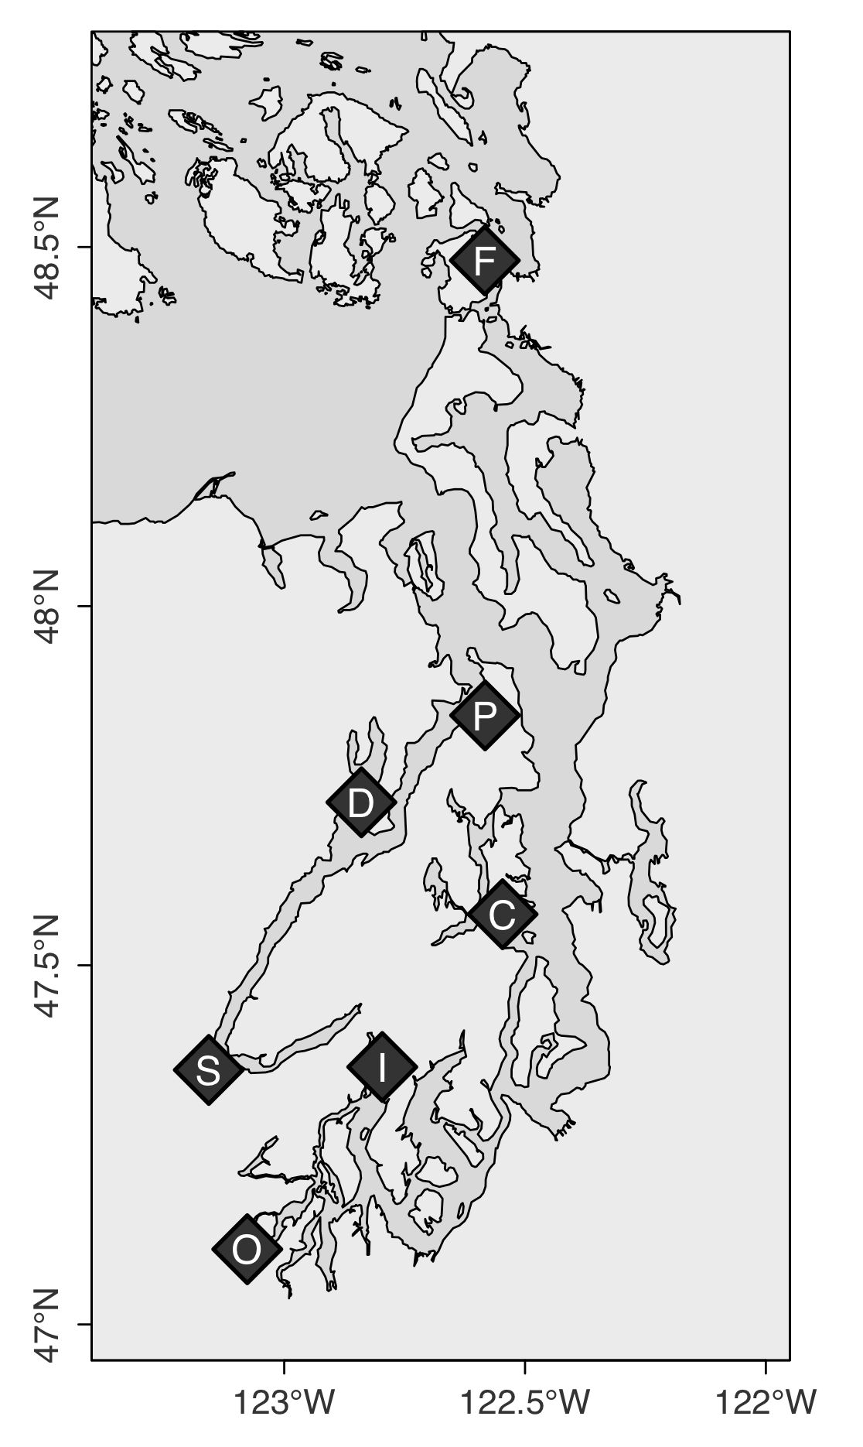

**Figure 2**

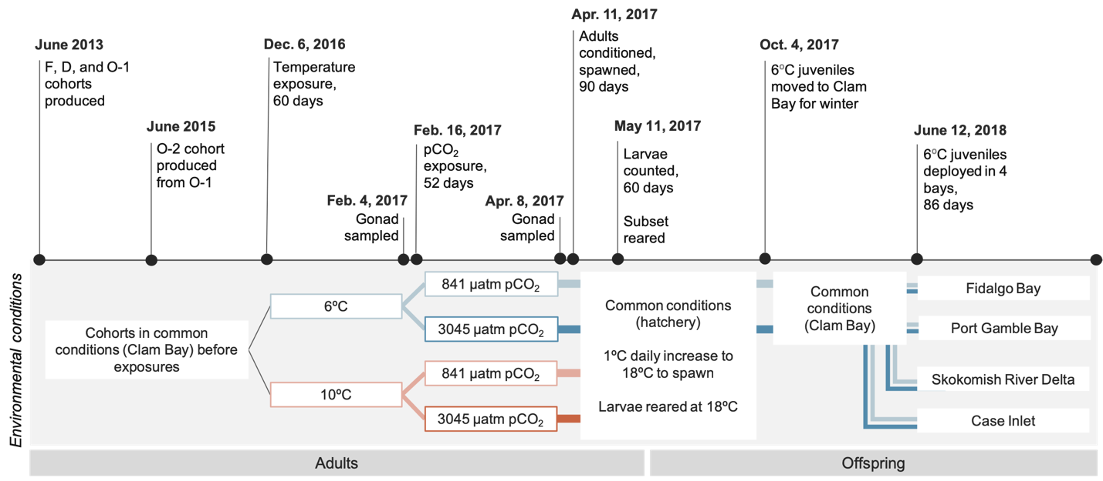

**Figure 3**

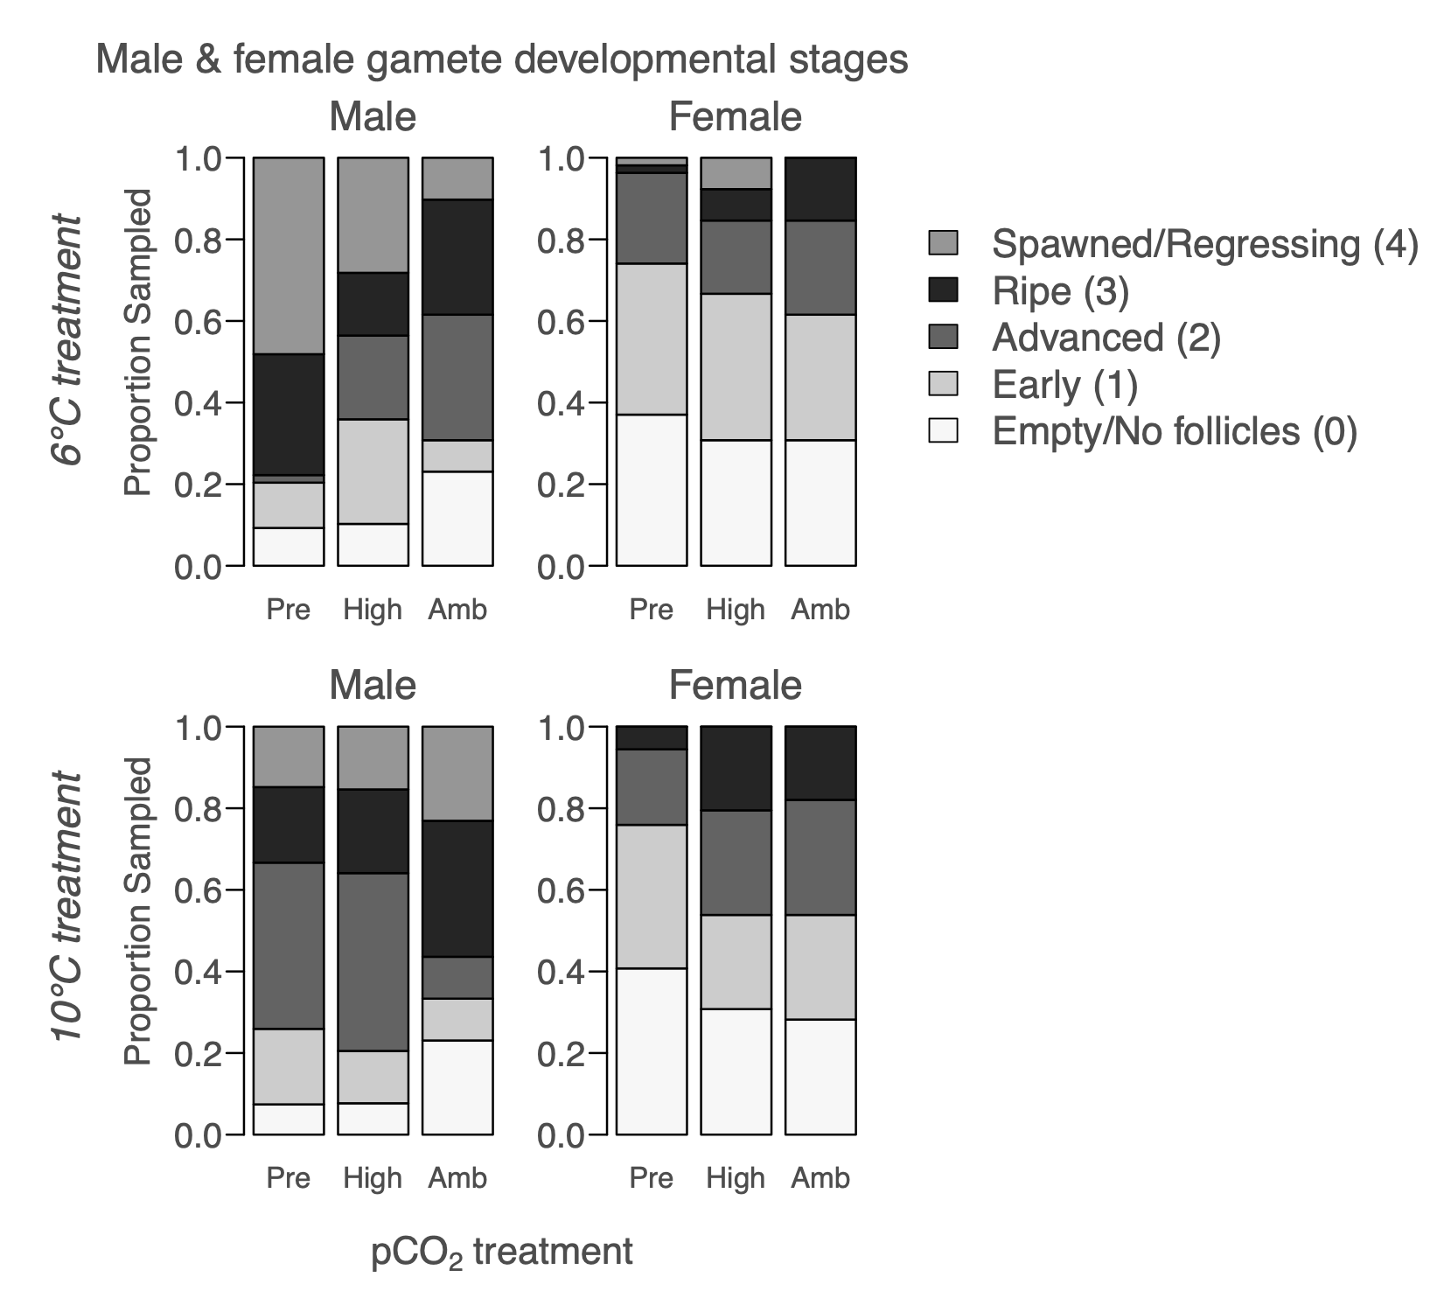

**Figure 4**

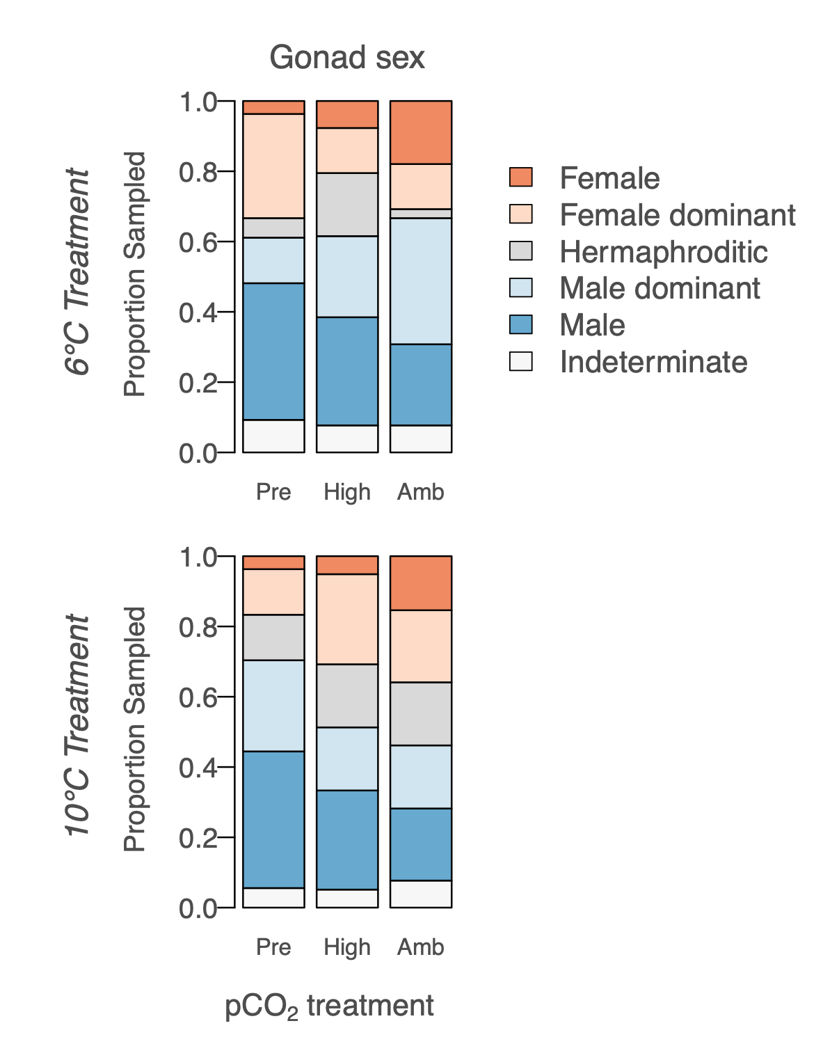

**Figure 5**

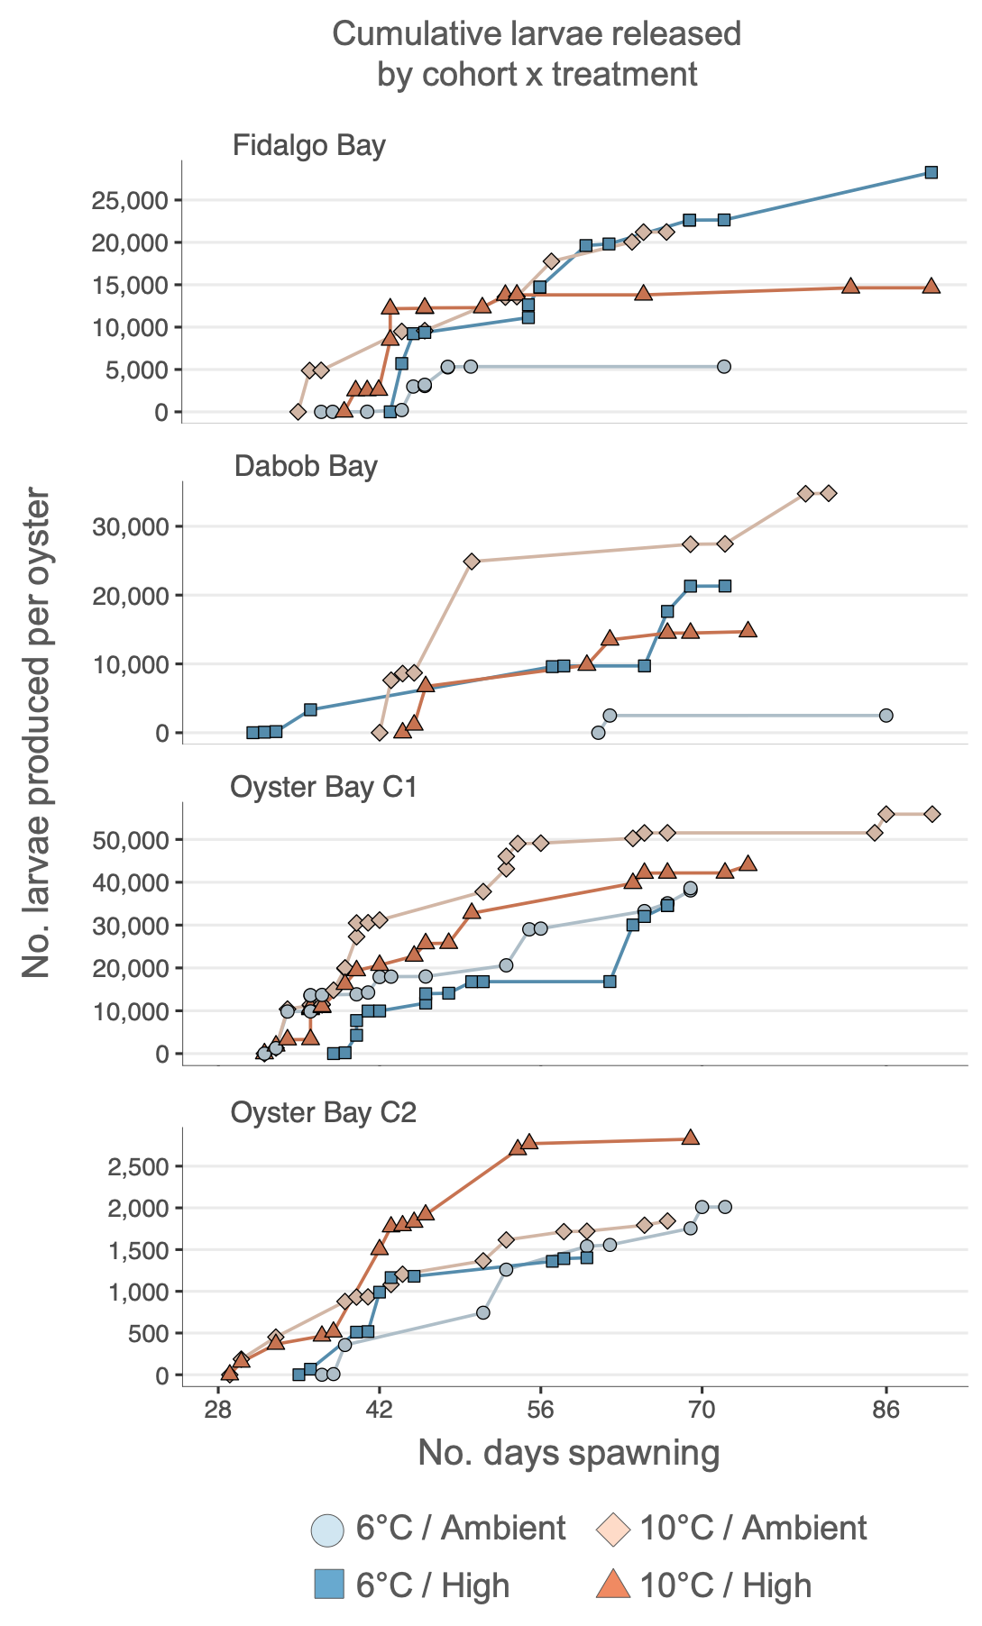

**Figure 6**

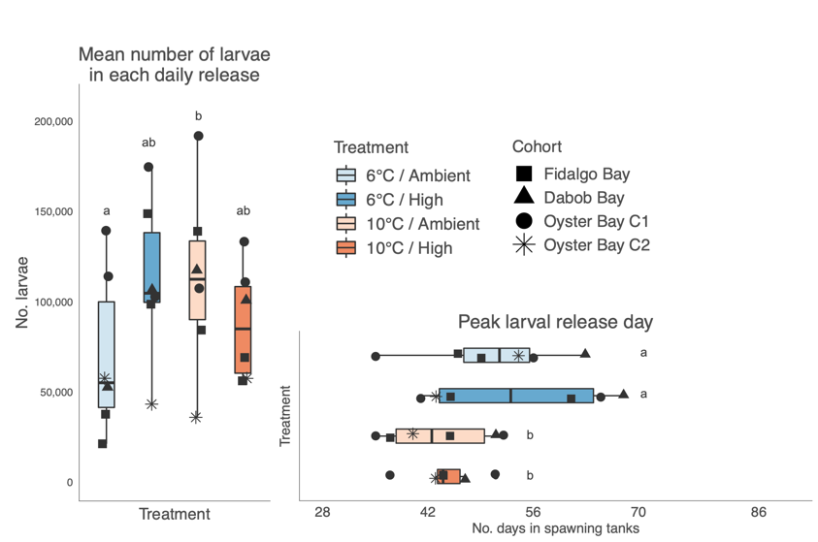

**Figure 7**

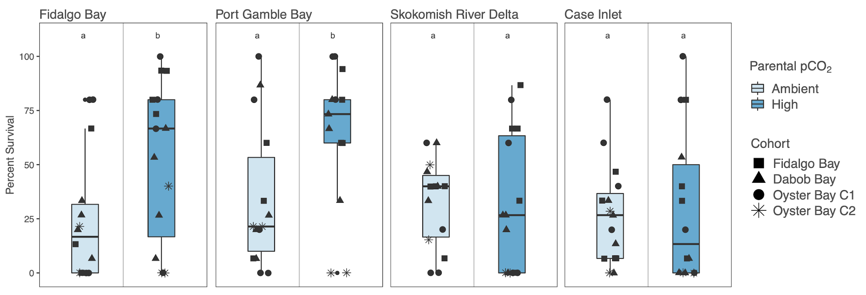

**Supplementary Materials**

**Instruments used in experimental treatments in the hatchery:**

* Temperature treatment manipulation and monitoring:
  + Chilling experimental water: Teco Aquarium Chiller, Model TK-500
  + Continuous temperature measurements: Onset HOBO Water Temperature Data Loggers, Model U22-001
* **pCO2 treatment manipulation and monitoring:**
  + pH monitoring: Durafet pH probes, Honeywell Model 51453503-505
  + pCO2 injection control: Honeywell Dual Input Analytical Analyzer, Model 50003691-501
  + Temperature monitoring: HOBO Pendant Temperature Data Loggers, Model UA-002-64
* **Carbonate chemistry measurements:** 
  + Temperature: Fisher Traceable Digital Thermometer, Model 15-077
  + Salinity: VWR Bench/Portable Conductivity Meter, Model 23226-505
  + pH: Mettler Toledo Combination pH Electrode, Model 11278-220
  + Total alkalinity: Mettler Toledo Excellence Titrator, Model T5Rondolino
* Algal dosing: metering pump – Iwaki EZ Controller, Model EZCD1

**Instruments used in field trial for continuous environmental data collection:**

* pH: Honeywell Durafet II Electrode, in custom-built housing
* Salinity: via conductivity, Dataflow Systems Ltd. Odyssey Conductivity and Temperature Logger
* Dissolved Oxygen: Precision Measurement Engineering MiniDOT Logger
* Temperature: via dissolved oxygen probes
* Chlorophyll: Turner Designs Cyclops-7F Submersible Sensor with PME Cyclops-7 Data Loggers

**Recipe for Tris buffer (0.08 M, 28.0 PSU):**

* 0.3603 mol of NaCl (J.T. Baker)
* 0.0106 mol of KCl (Fisher Scientific)
* 0.0293 mol MgSO4-(H2O)7 (Fisher Scientific)
* 0.0107 mol of CaCl2-2(H2O) (MP Biomedicals)
* 0.0401 HCl (J.T. Baker)
* 0.0799 mol of Tris base (Fisher Scientific)

Deionized water was added for a final volume of 1L

|  |  |  |  |  |  |  |  |  |  |  |  |  |
| --- | --- | --- | --- | --- | --- | --- | --- | --- | --- | --- | --- | --- |
| **Supplementary Table 1:**  Carbonate chemistry parameters for three time points during the pCO2 treatments, which are averages (± SE) from three replicate tanks per treatment. All parameters except for total alkalinity differed significantly between control/ambient (Amb.) and experimental/high (High.) tanks (One-way ANOVA). More details are available in *Venkataraman et al., 2019.* | | | | | | | | | | | | |
| Day | pH***  F(1,16) = 5838,  p = 6.12e-22 | | Total Alkalinity (µmol/kg)  F(1,16) = 1.38,  p = 0.257 | | pCO2 (µatm)***  F(1,16) = 235,  p = 5.44e-11 | | DIC (µmol/kg)*  F(1,16) = 7.12,  p = 0.0168 | | Ωcalcite***  F(1,16) = 529,  p = 1.10e-13 | | Ωaragonite***  F(1,16) =527,  p = 1.14e-13 | |
| Amb. | High | Amb. | High | Amb. | High | Amb. | High. | Amb. | High | Amb. | High |
| 5 | 7.82 ± 0.004 | 7.33 ± 0.002 | 2307.41 ± 25.45 | 2332.36 ± 31.05 | 747.51 ± 13.94 | 2481.23 ± 29.83 | 2233.41 ± 25.29 | 2408.51 ± 31.76 | 1.86 ± 0.02 | 0.62 ± 0.01 | 1.16 ± 0.012 | 0.58 ± 0.007 |
| 33 | 7.81 ± 0.005 | 7.31 ± 0.004 | 2747.00 ± 21.13 | 2917.60 ± 18.36 | 912.22 ± 12.69 | 3309.52 ± 7.22 | 2664.57 ± 19.99 | 3020.99 ± 17.99 | 2.23 ± 0.03 | 0.77 ± 0.02 | 1.40 ± 0.020 | 0.48 ± 0.014 |
| 48 | 7.82 ± 0.015 | 7.29 ± 0.004 | 2611.40 ± 31.01 | 2808.39 ± 12.24 | 863.47 ± 42.42 | 3343.89 ± 49.49 | 2533.28 ± 35.45 | 2920.52 ± 15.11 | 2.13 ± 0.06 | 0.68 ± 0.01 | 1.32 ± 0.035 | 0.42 ± 0.004 |

**Adult shell height**

Oysters sampled for histology were also measured for shell height using digital calipers (mm), defined as the maximum distance from the umbo along the dorsal/ventral axis. Shell height was compared between treatments prior to and after pCO2 exposure using two-way Analysis of Variance (ANOVA) for each cohort. Shell height was also compared among cohort using one-way ANOVA, excluding the younger O-2 cohort due to their smaller initial size.

Prior to pCO2 treatments, adult shell height did not vary between temperatures treatments, but did among F1 cohorts, with D smaller than F (p=0.043). After pCO2 treatment, D was smaller than both F (p=3.4e-6) and O-1 (p=3.5e-6). The O-1 cohort increased in size (p=0.019) in ambient pCO2, but not in high pCO2. No size differences among pre-pCO2 and post-pCO2 treatments were observed in the F, D or O-2 cohorts.

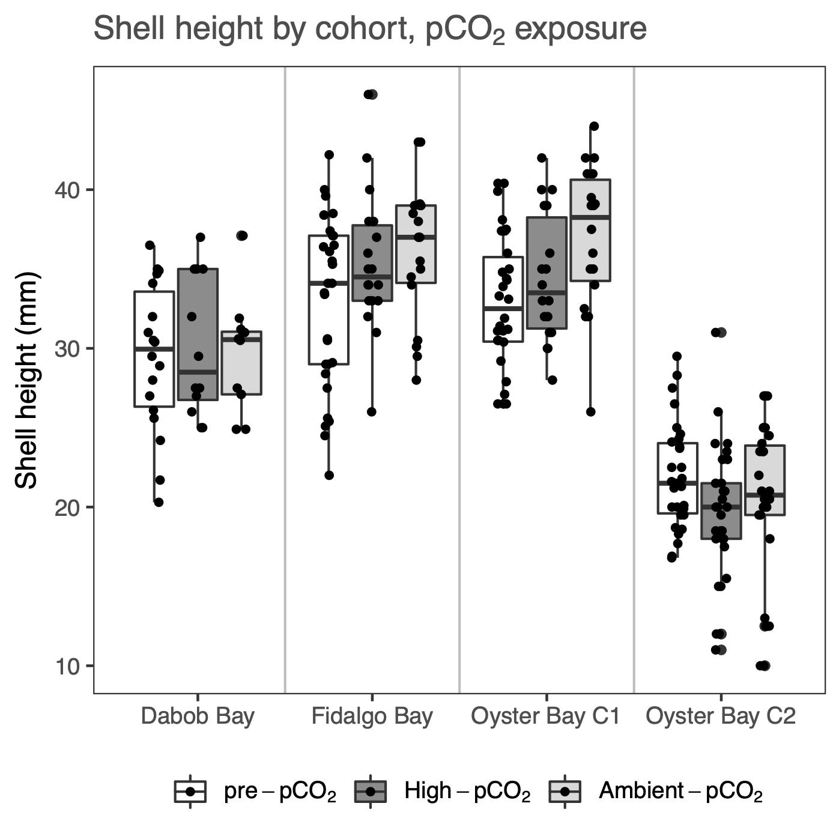

**Supplementary Figure 1:** Adult shell height for each cohort, after temperature treatment but before pCO2 treatment (“Pre-pCO2”), and after 52 days in High-pCO2 (3045±488 µatm, n=39), and Ambient-pCO2 (7.82±0.02, n=39).

|  |  |  |
| --- | --- | --- |
| **Supplementary Table 2:** Gonad stage designations, adapted from da Silva 2009 | | |
| Stage | Designation | Description |
| 0 | Inactive | Empty follicles, no presence of male or female gonad tissue. |
| 1 | Early gametogenesis | Gametes were mostly attached to the follicle wall. In the male developing line, spermatogonia and spermatocytes, very few spermatids; in the female developing line, mostly attached, developing ovogonia and early ovocytes. |
| 2 | Advanced gametogenesis | In the male developing line few spermatogonia, spermatocytes and spermatid balls were dominant, and few spermatozoa balls appeared in the follicle lumen; in the female developing line, few ovogonia present, ovocytes in vitellogenesis but attached were dominant, and ovocytes in post-vitellogenesis and located free in the follicle lumen less abundant. |
| 3 | Ripe | In both male and female developing lines, follicles contained mature gametes and sometimes a thin layer of primary germ cells. Abundant spermatozoa balls and mature ovocytes filled the follicle lumen, in male line and female line, respectively. |
| 4 | Spawned (full or partial), and/or resorbing | Gametes had been released, and follicles are dilated but lumen was empty, or contained residual mature gametes; residual oocytes of various sizes were sparsely distributed; residual spermatids were dissociated within follicle lumen. In some cases phagocytes were observed within follicles to re-absorb residual gametes. In many cases residual gametes of one sex remained, while developing gametes of the other sex were abundant. |

|  |  |  |  |
| --- | --- | --- | --- |
| **Supplementary Table 3:** Gonad sex designations, from da Silva 2009 | | | |
| Sex (uncollapsed, from da Silva) | Sex, collapsed for statistical analyses | Designation | Description |
| F | F | Female | Follicles contain only female gonad material (any stage) |
| HPF | F | Hermaphroditic, predominantly female | Follicles contain predominantly female but also some male gonad material |
| H | H | Hermaphroditic | Follicles contain approximately half male and half female gonad material |
| HPM | M | Hermaphroditic, predominantly male | Follicles contain predominantly male but also some female gonad material |
| M | M | Male | Follicles contain only male gonad material (any stage) |
| I | I | Indeterminate | Follicles are empty, collapsed, or only undifferentiated gonia are visible |

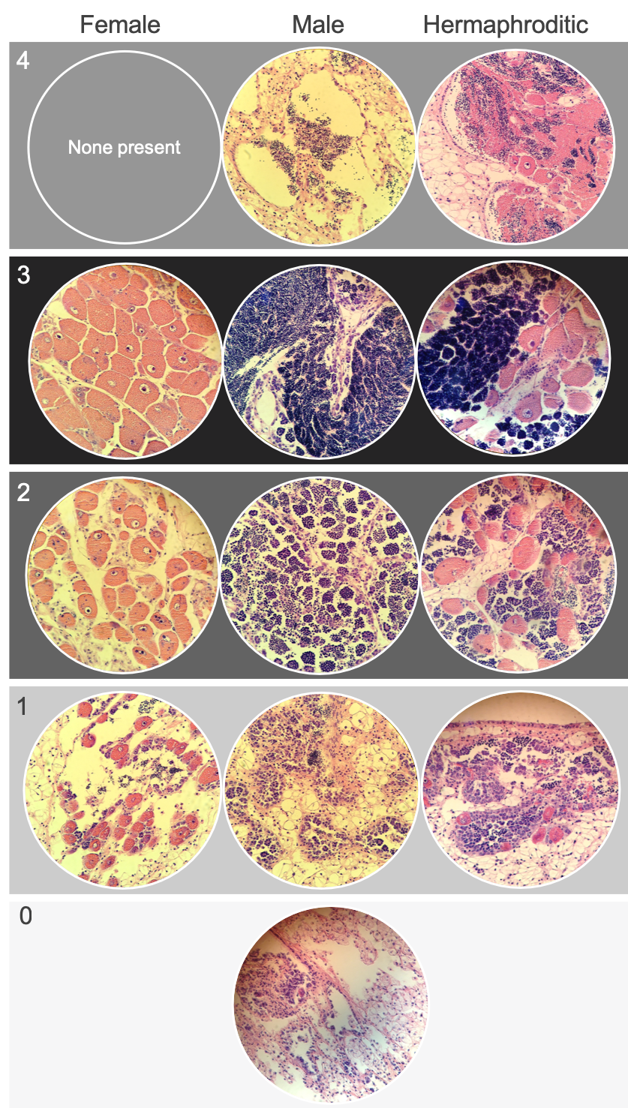**Supplementary Figure 2:** Examples of *Ostrea lurida* gonad stage designations. Stage 0 (no activity/sex differentiation); Stage 1 (early gametogenesis); Stage 2 (advanced gametogenesis); Stage 3 (late gametogenesis / ripe); Stage 4 (spawned and/or resorbing).

|  |  |  |  |  |  |  |  |  |  |  |  |  |  |  |  |
| --- | --- | --- | --- | --- | --- | --- | --- | --- | --- | --- | --- | --- | --- | --- | --- |
| **Supplementary Table 4**: Frequency of dominant gonad stages by cohort and pCO2 exposure, separated by winter temperature treatment (6°C, 10°C). Results of Chi-Square between pCO2 treatments are shown as p-values for dominant stage (Dom-stage), dominant sex (Dom-sex), Male stages (Male), and female stages (female). Across all cohorts in both 6°C and 10°C treatments, dominant stage and male stage differed by pCO2 treatments. Stage differences were detected between pre-treatment (pre-pCO2) and after treatment for ambient and high pCO2 separately, and are indicated by superscripts A and B: A= pre-treatment and ambient pCO2 differed; B=pre-treatment and high pCO2 differed (p<0.05). Stage and sex comparisons in bold indicate that they were significantly different between temperature treatments, prior to pCO2 treatments (“Pre” columns). | | | | | | | | | | | | | | | |
| *Dominant gonad stage for 6°C treatment, by cohort and pCO2 exposure* | | | | | | | | | | | | | | | |
|  | *Fidalgo Bay* | | | *Dabob Bay* | | | *Oyster Bay C1* | | | *Oyster Bay C2* | | | *All cohorts*  ***Dom-stageA:*** *p=0.036*  *Dom-sexA****:*** *p=0.202*  ***MaleA,B:*** *p=0.030*  *Female: p=0.219* | | |
| *Gonad Stage* | Pre  pCO2 | High pCO2 | Amb pCO2 | Pre  pCO2 | High pCO2 | Amb pCO2 | Pre  pCO2 | High pCO2 | Amb pCO2 | Pre  pCO2 | High pCO2 | Amb pCO2 | Pre  pCO2 | High pCO2 | Amb pCO2 |
| Spawned /  Resorbing (4) | 3 | 2 | 0 | 2 | 1 | 0 | 4 | 0 | 0 | 7 | 2 | 1 | *16* | *5* | *1* |
| Ripe (3) | 5 | 2 | 4 | 1 | 2 | 5 | 3 | 5 | 4 | 4 | 0 | 2 | *13* | *9* | *15* |
| Advanced (2) | 0 | 3 | 3 | 4 | 1 | 0 | 6 | 2 | 3 | 1 | 6 | 10 | *11* | *12* | *16* |
| Early (1) | 5 | 2 | 1 | 2 | 1 | 0 | 2 | 2 | 1 | 3 | 7 | 2 | *12* | *12* | *4* |
| Empty Follicles (0) | 2 | 0 | 1 | 0 | 1 | 1 | 0 | 0 | 1 | 0 | 0 | 0 | *2* | *1* | *3* |
| *Total Sampled* | *15* | *9* | *9* | *9* | *6* | *6* | *15* | *9* | *9* | *15* | *15* | *15* | *54* | *39* | *39* |
| *Dominant gonad stage for 10°C treatment, by cohort and pCO2 exposure* | | | | | | | | | | | | | | | |
|  | *Fidalgo Bay* | | | *Dabob Bay* | | | *Oyster Bay C1* | | | *Oyster Bay C2* | | | *All cohorts*  ***Dom-stage****A: p=0.008*  *Dom-sexA: p=0.73*  ***MaleA****: p=0.020*  *Female: p=1* | | |
| *Gonad Stage* | Pre  pCO2 | High pCO2 | Amb pCO2 | Pre  pCO2 | High pCO2 | Amb pCO2 | Pre  pCO2 | High pCO2 | Amb pCO2 | Pre  pCO2 | High pCO2 | Amb pCO2 | Pre  pCO2 | High pCO2 | Amb pCO2 |
| Spawned /  Resorbing (4) | 1 | 0 | 1 | 1 | 0 | 1 | 0 | 0 | 0 | 1 | 0 | 0 | *3* | *0* | *2* |
| Ripe (3) | 5 | 3 | 6 | 3 | 4 | 4 | 3 | 4 | 4 | 0 | 2 | 5 | *11* | *13* | *19* |
| Advanced (2) | 5 | 6 | 0 | 5 | 1 | 0 | 9 | 4 | 3 | 8 | 10 | 4 | *27* | *21* | *7* |
| Early (1) | 3 | 0 | 1 | 0 | 0 | 1 | 3 | 1 | 2 | 5 | 3 | 4 | *11* | *4* | *8* |
| Empty Follicles (0) | 1 | 0 | 1 | 0 | 1 | 0 | 0 | 0 | 0 | 1 | 0 | 2 | *2* | *1* | *3* |
| *Total Sampled* | *15* | *9* | *9* | *9* | *6* | *6* | *15* | *9* | *9* | *15* | *15* | *15* | *54* | *39* | *39* |

**Gonad sex and stage details and cohort traits**

Of all sampled oysters, 53.4% were hermaphrodites, 8.3% contained only female gametes, and 31.1% contained only male gametes, and the remaining 7.2% were indeterminate. Across all treatments, gonad sex (collapsed for comparison) differed significantly among cohorts (𝝌2=55.8, p=1.0e-4). Fifty percent of all O-1 oysters sampled were female or hermaphroditic-primarily female (HPF), while 33%, 24% and 11% of D, F, and O-2 were female or HPF. Male or hermaphroditic-primarily male oysters comprised 29%, 48%, 59% and 69% of O-1, D, F, and O-2 cohorts, respectively.

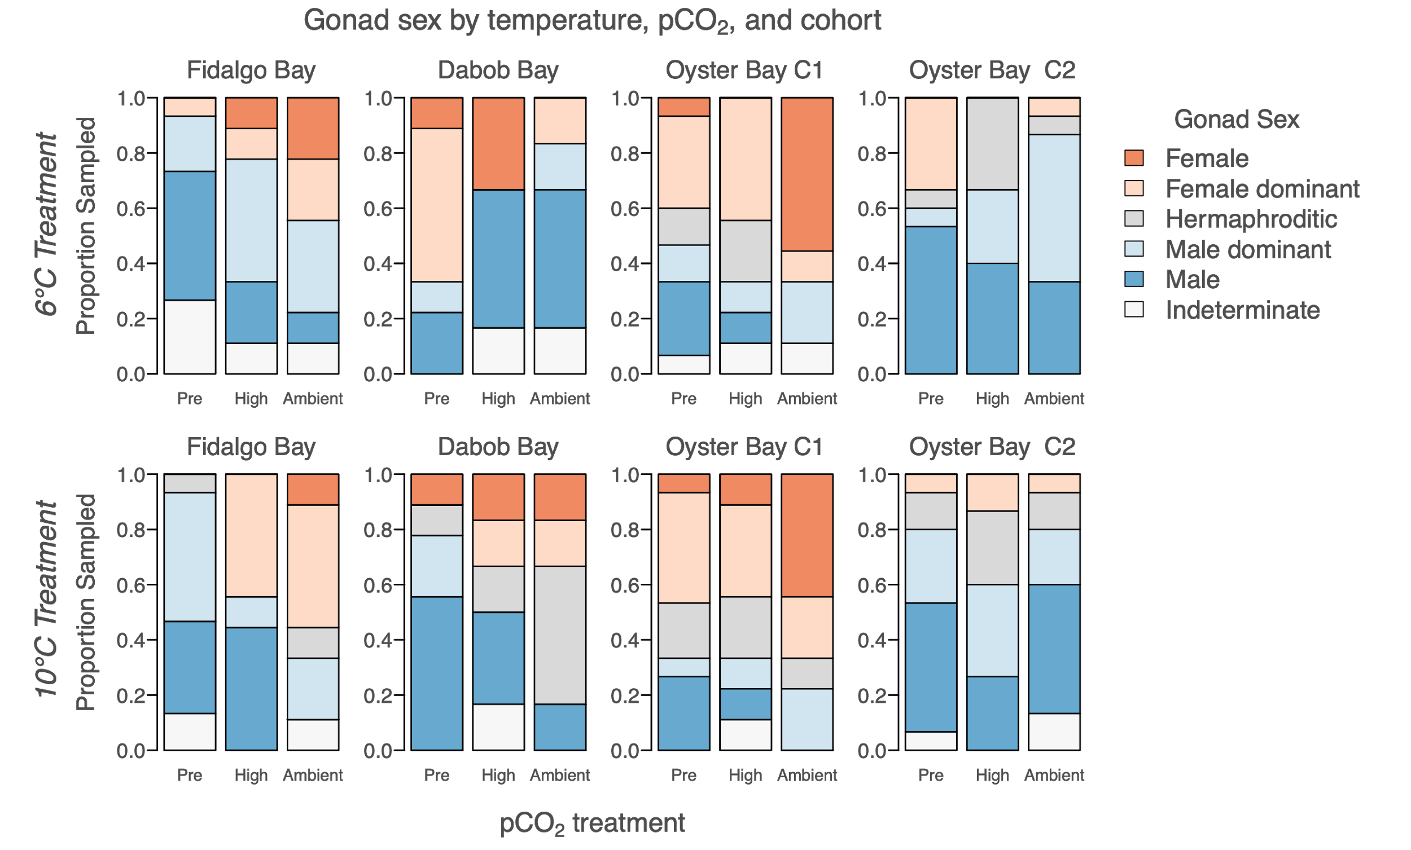

**Supplementary Figure 3**: Gonad sex for each cohort, after temperature treatment but before pCO2 treatment (“Pre”), and after 52 days in high pCO2 (3045±488 µatm, n=39, “High”), and ambient pCO2 (7.82±0.02, n=39, “Ambient”), separated by temperature treatment (6°C and 10°C).

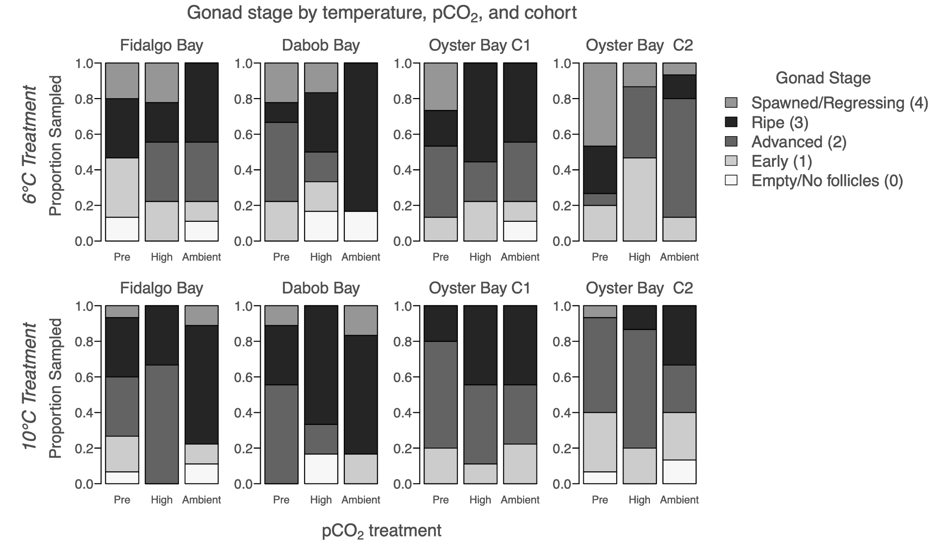

**Supplementary Figure 4:** Gonad stage of the dominant sex for each cohort, after temperature treatment but before pCO2 treatment (“Pre”), and after 52 days in high pCO2 (3045±488 µatm, n=39, “High”), and ambient pCO2 (7.82±0.02, n=39, “Ambient”), separated by temperature treatment (6°C and 10°C).

**Larval collection differences among cohorts**

Total larvae collected differed by cohort (F(3,8)=15.3, p=0.001). O-1 produced significantly more total larvae than F and O-2 (p=0.0094, p=0.0014, respectively), and D produced more total larvae compared to O-2 (p=0.022). Total larvae released by O-1, F, D, and O-2 was 10.1M, 3.6M, 2.7M and 2.1M, respectively. The same patterns were observed in average daily larvae released by cohort (F(3,20)=8.9, p=0.0009). Date of first larval release differed by cohort (F(3,8)=15.1, p=0.0012). Oyster Bay cohorts (O-1 and O-2) released larvae 9.9 days earlier than F and D cohorts on average. Larval pulse frequency differed by cohort (F(3,8)=9.8, p=0.0046). On average, O-1, O-2, F, and D released larvae 6.4±2.3, 8.0±2.9, 3.8±1.9, and 2.8±1.0 days, respectively. The O-1 cohort released larvae more frequently than F (p=0.017), and O-2 more frequently than both F and D (p=0.0066, p=0.043, respectively).

|  |  |  |  |  |  |  |  |  |  |  |  |
| --- | --- | --- | --- | --- | --- | --- | --- | --- | --- | --- | --- |
| **Supplementary Table 5**: Timing and magnitude of larval production in 4 *Ostrea lurida* cohorts previously exposed to different winter temperatures (6°C and 10°C), then pCO2 treatments (“Amb.” is Ambient=841±85 µatm, pH 7.82±0.02, High=3045±488 µatm). Fidalgo Bay, Dabob Bay, and Oyster Bay are previously identified as genetically distinct populations [(Jake E. Heare et al., 2017; J. Emerson Heare et al., 2018a)](https://paperpile.com/c/DMAOJn/4QuA+OwPR). Two Oyster Bay cohorts were used (O-1, O-2), with O-2 being the offspring of O-1 and likely all siblings. For each metric, total (“Tot.”) or mean (“Ave.”) of all cohorts combined for each treatment is shown. | | | | | | | | | | | |
| Cohort |  | *Fidalgo Bay*  *(2 reps)* | | *Dabob Bay* | | *Oyster Bay - F1*  *(2 reps)* | | *Oyster Bay - F2* | | *All cohorts combined* | |
| pCO2 treatment |  | Amb. pCO2 | High pCO2 | Amb. pCO2 | High pCO2 | Amb. pCO2 | High pCO2 | Amb. pCO2 | High pCO2 | Amb. pCO2 | High pCO2 |
| No. of broodstock | 6°C | 15/14 | 14/15 | 14 | 15 | 15/16 | 17/17 | 117 | 126 | Tot: 191 | Tot: 204 |
| 10°C | 15/14 | 14/14 | 9 | 16 | 17/17 | 15/15 | 115 | 111 | Tot: 177 | Tot: 185 |
| Date of first release | 6°C | 142/139 | 156/145 | 163 | 133 | 134/137 | 140/141 | 139 | 137 | Ave: 142 | Ave: 142 |
| 10°C | 145/137 | 144/141 | 144 | 146 | 135/134 | 134/137 | 131 | 131 | Ave: 138 | Ave: 139 |
| Date of max release | 6°C | 149/146 | 161/145 | 163 | 168 | 135/156 | 141/165 | 154 | 143 | Ave: 151 | Ave: 154 |
| 10°C | 145/137 | 144/144 | 151 | 147 | 135/152 | 151/137 | 140 | 143 | Ave: 143 | Ave: 144 |
| Date of last release | 6°C | 173/149 | 173/191 | 187 | 173 | 170/170 | 168/168 | 173 | 161 | Ave: 170 | Ave: 172 |
| 10°C | 158/168 | 184/191 | 182 | 175 | 191/187 | 175/173 | 166 | 170 | Ave: 175 | Ave: 178 |
| Ave. daily larvae released  (x103) | 6°C | 21/38 | 99/127 | 53 | 107 | 139/114 | 103/175 | 58 | 43 | Ave: 79 | Ave: 110 |
| 10°C | 139/84 | 58/56 | 117 | 101 | 192/107 | 133/111 | 36 | 57 | Ave: 108 | Ave: 88 |
| Total larvae released (x103) | 6°C | 127/150 | 591/892 | 105 | 959 | 697/  1,482 | 719/  1,397 | 518 | 389 | Tot: 3.08M | Tot: 4.95M |
| 10°C | 695/421 | 345/393 | 939 | 705 | 1,918/  1,502 | 933/  1,441 | 466 | 689 | Tot: 5.9M | Tot: 4.5M |
| Total larvae released per broodstock  (x103) | 6°C | 2.4/3.0 | 11.7/16.5 | 2.5 | 21.3 | 12.9/25.7 | 11.7/22.8 | 2.0 | 1.4 | Ave:  6.6 | Ave:  13.5 |
| 10°C | 1.3/8.4 | 6.8/7.8 | 34.8 | 14.7 | 31.3/24.6 | 17.3/26.7 | 1.8 | 2.8 | Ave:  18.8 | Ave:  11.7 |
| Maximum release (x103) | 6°C | 111/140 | 247/308 | 105 | 356 | 462/484 | 250/809 | 133 | 131 | Ave: 239 | Ave: 350 |
| 10°C | 248/246 | 298/186 | 437 | 268 | 555/407 | 378/379 | 108 | 241 | Ave: 333 | Ave: 292 |
| No. big release days (>10k) | 6°C | 2/1 | 4/4 | 1 | 4 | 3/8 | 5/5 | 6 | 5 | Tot: 21 | Tot: 27 |
| 10°C | 3/3 | 2/3 | 5 | 5 | 7/7 | 5/10 | 11 | 10 | Tot: 36 | Tot: 35 |

**Larval rearing methods**

Larvae collected between May 19 and July 6 were separated by treatment and cohort and reared over 67 days from May 19 to July 25. For all culture tanks, seawater was heated to 18°C in a common 1,610-L recirculating reservoir (1610 L) using Aqua Logic digital temperature controllers (TR115SN), dosed with live algae cocktail via an Iwaki metering pump to achieve 100,000 cells/mL, and distributed to culture tanks. Larvae were grown in two connected 19-L flow-through tanks (19-L; 8-L/hr) with aerated, filtered seawater (1 µm) at 18°C. The two-tank larval system was used to cull dead larvae: water flowed from one 19-L tank where larvae were added but non-swimming larvae would remain (“mortality tank”) to the next (“live tank”), carrying live, swimming larvae which were then contained on a 100 µm screen. Twice weekly, live larval tanks were screened into three size classes: 100 µm < X < 180 µm (“100 µm”), 180 µm < X < 224 µm (“180 µm”), >224 µm (“224 µm”, which is when *O. lurida* larvae are near metamorphosis). Each size class was subsampled and counted, then the 100 µm and 180 µm classes returned to larval tanks. The number of live larvae returned to culture tanks informed stocking of newly released larvae. To maximize genetic diversity of offspring, newly spawned larvae (≲ 50,000) were added to culture tanks continuously to a maximum stocking density of 200,000 larvae (~10 larva/mL) (PSRF pers. communication & [FAO manual](http://www.fao.org/docrep/007/y5720e/y5720e06.htm)). The contents in the mortality buckets were collected during biweekly screenings on a 100 µm screen to count live and dead oysters, but live were not kept.

During the twice weekly screening days, larvae that were larger than 224 µm were moved to downwelling setting silos, separated by cohort, temperature and pCO2 treatment. Setting tanks were 180 µm silos with 18°C filtered seawater (1 µm) dosed with live algae, which then flowed into each silo from 8-L/hr irrigation drippers. Pacific oyster shell fragments (224 - 450 µm) were sprinkled into each silo to cover the surface to provide a settlement substrate. Silos were cleaned with freshwater (18°C) several times per week. Live, metamorphosed oysters were counted on August 12 for survival rate from 224 um to post-metamorphosis (“post-set”), then transferred to 450 µm silos with ~17°C upwelling filtered seawater (5 µm) to continue rearing. Oysters were fed live algae using a gravity algae header tank, and rinsed 1-2 times per week with freshwater. On October 4, when oysters were between 13-20 weeks old, all groups were moved to screen pouches separated by cohort x temperature x pCO2, affixed to the inside of shellfish cages, and hung in Clam Bay until June 2018.

|  |  |  |  |  |  |  |  |  |  |  |  |
| --- | --- | --- | --- | --- | --- | --- | --- | --- | --- | --- | --- |
| **Supplementary Table 6**: Tank densities during offspring rearing. | | | | | | | | | | | |
|  |  | *Fidalgo Bay*  *(2 replicates)* | | *Dabob Bay* | | *Oyster Bay - F1*  *(2 replicates)* | | *Oyster Bay - F2* | | *All* | |
|  |  | Amb pCO2 | High pCO2 | Amb pCO2 | High pCO2 | Amb pCO2 | High pCO2 | Amb pCO2 | High pCO2 | Amb pCO2 | High pCO2 |
| Cumulative larvae stocked | 6°C | 169,475 | 353,916 | 65,667 | 255,371 | 477,403 | 532,417 | 353,769 | 179,717 | 1,066,314 | 1,321,421 |
| 10°C | 319,277 | 271,016 | 283,858 | 310,875 | 937,920 | 660,451 | 324,166 | 237,790 | 1,865,221 | 1,480,132 |
| Mean, larvae density (in 20L tank) | 6°C | 29,148  ±  33,256 | 54,265  ±  44,431 | 22,000  ±  22,036 | 43,293  ±  43,168 | 50,260  ±  51,338 | 58,662  ±  64,276 | 47,231  ±  38,553 | 31,877  ±  30,341 | 39,270  ±  40,579 | 46,777  ±  47,718 |
| 10°C | 40,150  ±  47,430 | 29,486  ±  30,781 | 49,584  ±  33,070 | 56,081  ±  49,214 | 88,962  ±  71,752 | 74,562  ±  72,312 | 53,588  ±  50,765 | 32,423  ±  41,853 | 60,478  ±  5,7472 | 48,774  ±  54,447 |
| Median larvae density | 6°C | 18,013 | 42,783 | 19,117 | 26,160 | 33,797 | 32,608 | 45,667 | 20,800 | 26,397 | 28,192 |
| 10°C | 16,000 | 20,650 | 50,317 | 45,833 | 83,577 | 48,800 | 29,833 | 7,877 | 50,317 | 34,935 |
| Total eyed larvae | 6°C | 11,119 | 11,780 | 2,496 | 10,686 | 11,931 | 6,029 | 22,186 | 9,735 | 47,732 | 38,230 |
| 10°C | 3,737 | 2,978 | 13,862 | 19,815 | 59,929 (split) | 10,670 | 13,828 | 2,910 | 91,356 | 36,373 |
| Total post set (singles) | 6°C | 1,503 (split) | 670 | 501 | 834 | 124 | 192 | 356 | 334 | 2,484 | 2,030 |
| 10°C | 626 | 75 | 1311 | 1091 | 52 | 34 | 246 | 113 | 2,235 | 1,313 |
| Juvenile shell height (mm) | 6°C | 9.0±2.7 | 8.4±3.5 | 6.5±1.9 | 4.9±2.3 | 11.2±3.5 | 11.0±3.4 | 11.0±3.7 | 7.5±3.0 |  |  |
| 10°C | 9.7±3.0 | 12.3±5.4 | 7.0±2.3 | 6.6±2.9 | 11.0±3.8 | 12.2±4.2 | 10.7±3.7 | 13.4±4.4 |  |  |
| Juveniles deployed | 6°C | 240 | 257 | 240 | 240 | 85 | 77 | 122 | 90 | 677 | 664 |
| Juveniles survived | 6°C | 60 | 159 | 72 | 81 | 32 | 45 | 22 | 4 | 186 | 289 |

**Larval survival estimates**

Larval survival was estimated from both twice-weekly larval counts and cumulative survival counts. Percent survival between biweekly larval counts was calculated by summing the number of live larvae in all size classes (100 µm, 180 µm, 224 µm), dividing by the number of live larvae restocked after the previous count, plus all new larvae added since. Cumulative percent survival from newly released larvae (“new larvae”) to the near-metamorphosis stage (“eyed larvae”), and to post-metamorphosis (“post-set”) were compared between treatments based on total number of new larvae stocked in culture tanks and eyed larvae in setting tanks over the larval rearing period. During larval rearing, culture tank densities were capped at 200,000 larvae (~10 larvae/mL), but ranged during the 67 day larval rearing period due to varying mortality and larval release timing. Daily tank densities were estimated from twice-weekly larval counts and number of new larvae added, then compared between temperature x pCO2 treatments using a Kruskal-Wallis Test.

Biweekly larval survival, cumulative survival from new to eyed larvae, and survival from eyed larvae to post-set were compared among cohort x temperature x pCO2 treatments using ANCOVA on fitted linear regression models. For biweekly percent survival, square-root arcsine transformation was applied, and biweekly tank density was included as a random effect. For cumulative survival models, mean stocking density and total larvae stocked in culture tanks were examined as candidate random effects with Pearson’s correlation using pairs and cor. For post-set survival, cumulative eyed larvae stocked in setting tanks and percent survival to eyed larvae stage were also tested and survival data was log-transformed. Tank density factors that correlated significantly with cumulative survival were considered as random effects in full regression models alongside cohort, temperature and pCO2. All models were optimized using stepwise deletion and selected based on AIC value, adjusted R-squared, and F-statistic.

**Larval survival results**

Larval survival between biweekly counts did not differ by pCO2 or temperature, but did differ by cohort (F(3,230)=5.73, p=8.5e-4). Pairwise tests indicate that O-1 survival was significantly lower than D (p=3.8e-4), O-2 (p=5.4e-4), and F (p=0.019). Mean biweekly survival of D, F, O-2, and O-1 cohorts was 62±22%, 59±24%, 55±24%, and 49±28%, respectively. Cumulative survival from new- to eyed-larvae was low across all treatments, and did not differ by parental temperature treatment (F(1,14)=2.3, p=0.15), parental pCO2 (F(1,14)= 1.9, p=0.19), or cohort (F(3,12)= 1.4, p=0.29) (Table 3). Cumulative survival from eyed larvae to post-set) ranged from 0.2% to 26.5% and differed by cohort (F(3,11)=3.8, p=0.04). Pairwise tests revealed that this was influenced by low survival in the O-1 group and significance was not strong after removing O-1 (F(2,9)=4.1, p=0.06). No survival differences through metamorphosis were detected between pCO2 or temperature treatments.

Tank density prior to each biweekly screening was a significant factor influencing survival between bi-weekly counts (F(1,230)=10.4, p=0.0015) and therefore was included as a random effect in the biweekly survival regression model. Mean stocking densities across the 67-day rearing period in O-1, D, O-2, and F were 76,500±71,100, 54,400±424000, 47,000±46,200, and 43,500±42,700, respectively. No random effects were retained in the cumulative survival from new- to eyed-larvae model. Total larvae stocked in larval culture tanks correlated with survival from eyed-larvae to post-set (i.e. through metamorphosis), and therefore was included as a random effect in the post-set survival model.

The number of days between first and last larval collection, and first and last eyed larvae varied by cohort, although this was not significant. Across treatments, eyed larvae were present soonest in F (14.5±2.5 days), followed by O-1 (16.5±1.75 days), O-2 (17.25±1.25 days), and lastly D (18.25±3 days) (F(3,12)=2.0, p=0.16). The number of days between stocking the last batch of newly released larvae, and collecting the last eyed larvae were 22±5.8, 23.25±7.4, 29.5±4.7, and 32±4.8 for O-1, F, D, and O-2, respectively.

|  |  |  |  |  |  |  |  |  |  |  |  |
| --- | --- | --- | --- | --- | --- | --- | --- | --- | --- | --- | --- |
| **Supplementary Table 7**: Larval survival estimates by parental treatment and cohort. | | | | | | | | | | | |
| *Larval survival, by treatment and cohort* | | | | | | | | | | | |
|  |  | *Fidalgo Bay* | | *Dabob Bay* | | *Oyster Bay - F1* | | *Oyster Bay - F2* | | *All cohorts* | |
|  |  | Amb pCO2 | High pCO2 | Amb pCO2 | High pCO2 | Amb pCO2 | High pCO2 | Amb pCO2 | High pCO2 | Amb pCO2 | High pCO2 |
| Average biweekly larval survival | 6°C | 56±25% | 62±26% | 69±18% | 49±21% | 44±23% | 52±27% | 60±24% | 59±28% | 56±24% | 56±26% |
| 10°C | 50±18% | 51±26% | 58±25% | 70±18% | 49±30% | 46±29% | 63±25% | 55±21% | 55±25% | 56±25% |
| Cumulative survival to eyed larvae | 6°C | 8.5% | 3.0% | 5.1% | 4.7% | 2.7% | 1.2% | 6.7% | 5.7% | 5.7±2% | 3.6±2% |
| 10°C | 1.3% | 1.4% | 5.2% | 6.6% | 4.2% | 0.7% | 4.4% | 1.0% | 3.8±1% | 2.4±3% |
| Cumulative survival, eyed larvae to post set | 6°C | 13.8% | 5.9% | 26.5% | 9.3% | 1.1% | 3.6% | 1.7% | 3.5% | 10.8  ±10% | 5.6  ±2.7% |
| 10°C | 18.5% | 2.7% | 9.7% | 6.0% | 0.2% | 0.7% | 1.9% | 5.8% | 7.6±8% | 3.8±3% |



**Supplementary Figure 5**: Juvenile mass change during field trial was significantly less in the Dabob Bay cohort than other 3 cohorts (left), and was significantly less in Fidalgo Bay than in Port Gamble Bay and Case Inlet (right). Mean mass / oyster represents the average final mass per oyster minus average initial mass within each deployment bag.



**Supplementary Figure 6**: Juvenile proportion survival ~ environmental summary statistics. Model selection indicates that survival was significantly related to mean temperature (“Temp.mean”), mean pH (“pH.mean”), and dissolved oxygen standard deviation (“DO.sd”).